 **Th*e* Ministry of Higher Education**

**Modem Academy In Maadi**

**For CS Department**

**Shtably**

**Prepared by :**

**AnTon Osama Wesa**

**Mina Mamdouh Mohareb**

**Mostafa Ahmed Soliman**

**Mina Rizkallah Goda**

**Almo'tasem Bellah Anwer Elsayed**

Supervisor: Dr/ Mohamed Awad

Assistant : Eng/ Mina Gerges

2021-2022

CS[103]



**Th*e* Ministry of Higher Education**

**Modem Academy In Maadi**

**For CS Department**

**Modern Academy In Maadi**

**Shtably cs(103)**

**Supervisor**:

Dr/Mohamed Awad

**Assistant**:

Eng/.Mina Gerges

**Team Member**

1. Anton Osama Wesa © 119000515
2. Mina Mamdouh Mohareb 119000380
3. Mostafa Ahmed Soliman 119000488
4. Mina Rizkallah Goda 119000671
5. Almo'tasem Bellah Anwer Elsayed 119000704

**cs(103)**



**Acknowledgment**

We are extremely thankful to the role of our educational institute

[Modern Academy for Computer Science and Management Technology]

Which enriched our Educational experience through its great management .

**Prof.Dr Nabil Deabes**

For maintaining the academy's development which had a huge reflect on our performance.

Expressing thanks to’’ **Dr. Awad’’** and ‘’ **Eng. Mina Gerges’’** is more than a must as they encouraged and guided us all the way through the project period with patience and care. Of course we are indebted to many people to establish this project and stuff of the department of Computer Science are to be thanked specially. At the end we must mention that everyone that has helped us to produce this project beginning with those who are working in our academy to everybody outside deserves to be appreciated.

**Abstract :-**

In the beginning, and in a nutshell, the idea of this project revolves around two important parts.

**The first** is that it is possible The customer has to create a maintenance request and request a maintenance worker and complete the task. In **the second half of the project**, we added a **store** to purchase maintenance supplies of all kinds so that everything is available on the application and to facilitate the maintenance process for the customer, and you can also submit a request to work in this application.

**Table of contents**

**Chapter 1 [introduction] ………………………………………………………6**

1-Overview ……………………………………………………………………………………………………………………………………………00

2-Poblem Definition ……………………………………………………………………………………………………………………………..00

3-Solation App …………………………………………………………………………………………………………………………………………..00

4-Scope …………………………………………………………………………………………………………………………………………..00

5-Objectve ………………………………………………………………………………………………………………………………………..00

**Chapter 2 [Historical Background ] ……………………….…………00**

* **Chapter 3 [Analysis and System Design & SDLC ]....………….00**

**Chapter 4 [Design & System Implementation ]….……………..00**

* **Chapter 5 [Testing]…………………………..…………………………….00**

**Chapter 6 [Tools]…………………………………………………………….00**

**Chapter 7 [Conclusion and future work ]..………………………00**

**Reference ……………………………………………………………………….00**

**Chapter One**

**Introduction**

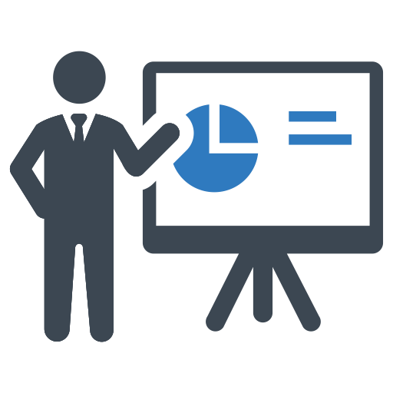

1. **Overview**

Everyone in this life at different times needs many different maintenance works in his house or when he buys a new house he needs rehabilitation in order to be able to live in it, through our project you can accomplish all these tasks and you can use the project on the web or Android phones Or Apple Phones.

* People were having a difficult time finding someone to address their house's issues, such as plumbing, electricity, and painting, and it was difficult to trust them. We don't feed any personal information to our employees because we don't have any. information about them, and this was what was causing the problem. In terms of the circumstances, it is getting worse and more challenging everything.

1. **Problem Definition**

* It takes a long time for people to locate occupations that pay well. They have a supply of information inside, and it is also safe for them. makes people believe in them
* When a person wants to buy any of the maintenance supplies, he does not find the right place easily because of the high prices, the large number of random stores, and the price discrepancy between merchants.

1. **Solution App**

* We have provided the information that the client needs in order to choose the reliable worker through the evaluation and previous work with him.
* We have provided a store to buy any of the paint products, electrical tools, sanitary ware and everything your home needs, through which you can see the prices and stores according to the types.

1. **Scope**

* This project is about facilitating communication between the client and the worker so that they can feel confident in dealing with each other. The client also trusted the worker because he knew everything about him, including his name, address, shape, and phone number, thanks to the initiative.
* Why People trusted the workers project because when they applied for a job, the computer checked everything about them to ensure that the information they supplied was correct and that they could be trusted.

The Software Development Life Cycle (SDLC) refers to a methodology with clearly defined processes for creating high-quality software. in detail, the SDLC methodology focuses on the following phases of software development:

**5-The Software Development Life Cycle (SDLC)**

**Requirement analysis**

**Planning**

**Software design such as architectural design**

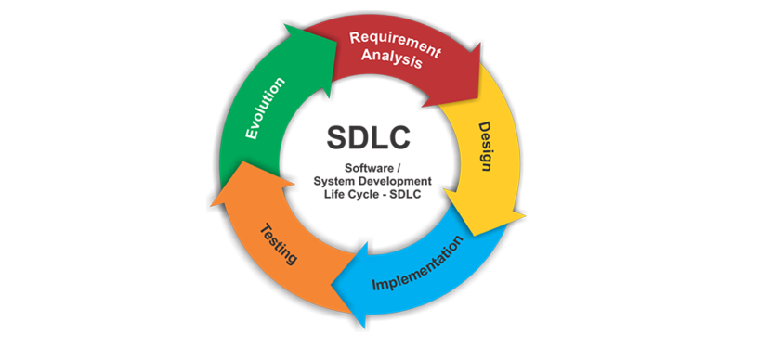**Software development**

**Testing**

**Deployment**

Figure 1 SLDC Phase



**Chapter Two**

**Historical Background**

In this chapter, we will talk about the applications that exist in the real world and are similar to our application, and also about the differences between the old applications and this application, and what distinguishes this application from the one currently in the Google Play Store

In the beginning,

**what are the applications that deal with the same idea in the Egyptian market?**

1. **Primo Application 2-Fixawy**



Figure 3 Fixawy logo

Figure 2 Primo logo

**What are the advantages and disadvantages of this application, and what is new about the Shatbly application?**

Some of the flaws are very poor application design,

and there is a combination of iOS designs in an application that works on Android phones

And the colors are stressful to the eyes

The software is not easy to use

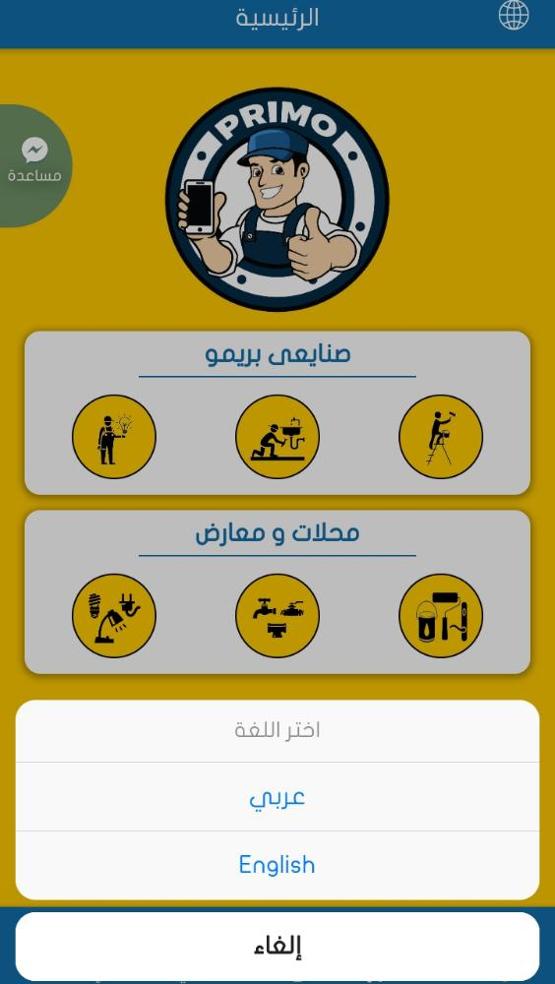It is not safe at all, and anyone can post any content without referring to the admin

And this is one of the annoying flaws is the presence of UI with iOS system on Android phones

Figure 4 SS of the mistake

**What does it offer and what is new in our application and what distinguishes it from previous applications?**

* We made two versions of iOS and Android, as well as a website that performs the same operations at the same time
* The application supports Arabic and English and supports the dark mode feature
* Each user has a QR code for each one to identify his identity.
* One of the features of the application is that there is a special **Store** for all products related to the preparation of apartments and real estate, and any user can shop on this store, and only two people have the right to publish in this store, and they are the admin from the dashboard page and through the merchant.
* We did a search in the application by voice speaking

**[Speech To Text] .**

* In the payment stage, we used the **machine Learning** in the payment stage, which is when paying via Visa, you photograph the Visa Card, and the application takes the numbers from the card and puts them in the boxes designated for it by itself without the need to do that by the user.
* There is also a **chat bot** to facilitate the process of using the application and provide assistance to the user.

**Chapter 3**

**[Analysis and System Design ]**



In this chapter, we will review some of the diagrams that we designed in order to create this project.

**1.1 Data Flow Diagram Level 0**

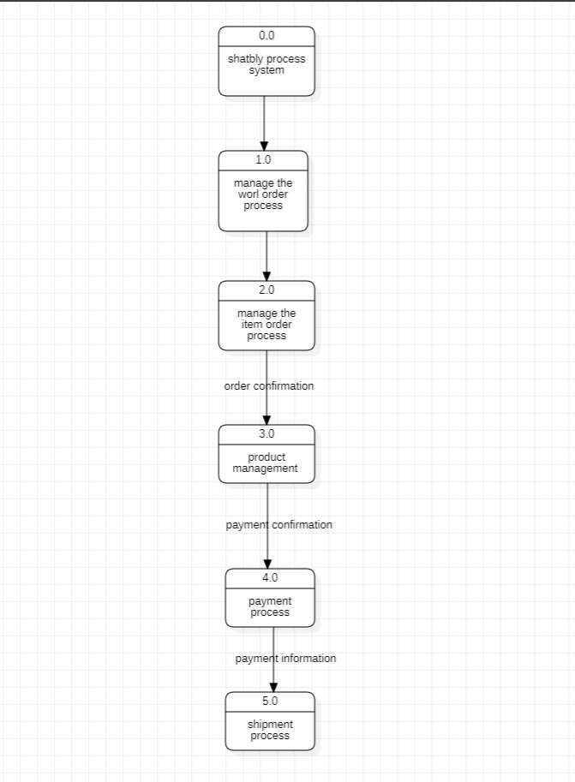

DFD Level 0 is also called a Context Diagram. It's a basic overview of the whole system or process being analyzed or modeled. It's designed to be an at-a-glance view, showing the system as a single high-level process, with its relationship to external entities.

**1.2 Data Flow Diagram Level 1**

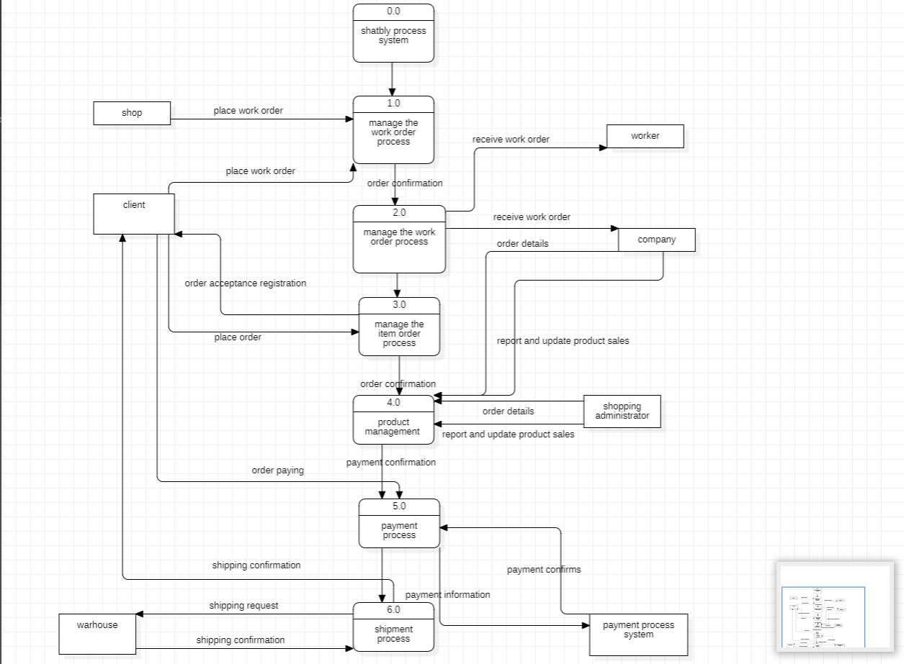in a level 1 data flow diagram, the single process node from the context diagram is broken down into sub processes. As these processes are added, the diagram will need additional data flows and data stores to link them together.

**2.Class Diagram**

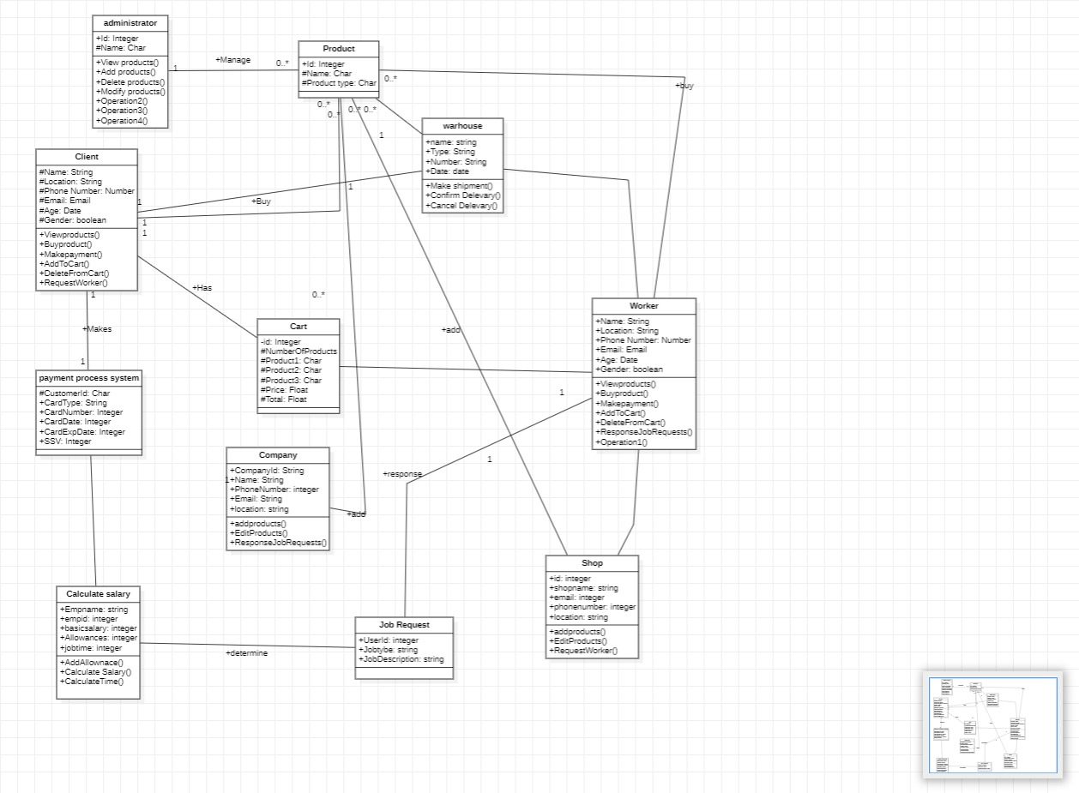In software engineering, a class diagram in the Unified Modeling Language is a type of static structure diagram that describes the structure of a system by showing the system's classes, their attributes, operations, and the relationships among objects.

**3.ERD [Data Base Schema]**

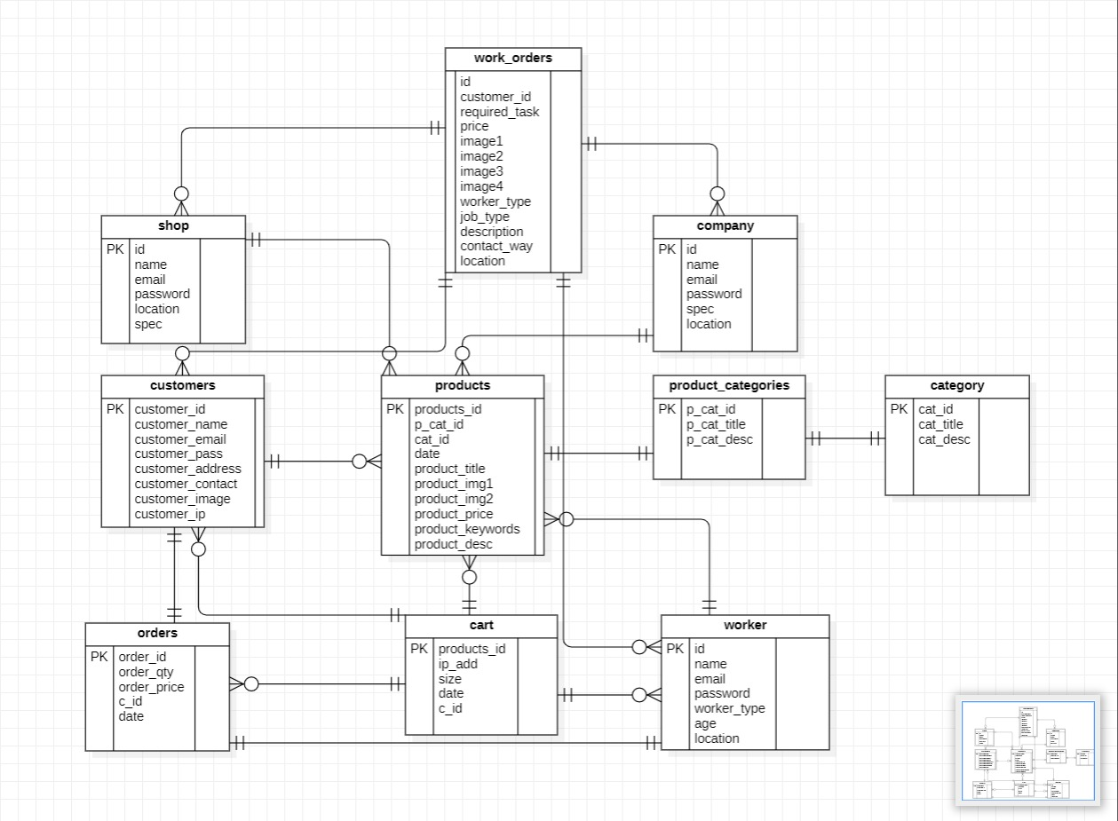An Entity Relationship (ER) Diagram: is a type of flowchart that illustrates how “entities” such as people, objects or concepts relate to each other within a system. ER Diagrams are most often used to design or debug relational databases in the fields of software engineering, business information systems, education and research. Also known as ERDs or ER Models, they use a defined set of symbols such as rectangles, diamonds, ovals and connecting lines to depict the interconnection of entities, relationships and their attributes.

**4.1 Use Case [ Make Order ]**

A use case diagram is a graphical depiction of a user's possible interactions with a system. A use case diagram shows various use cases and different types of users the system has and will often be accompanied by other types of diagrams as well. The use cases are represented by either circles or ellipses.

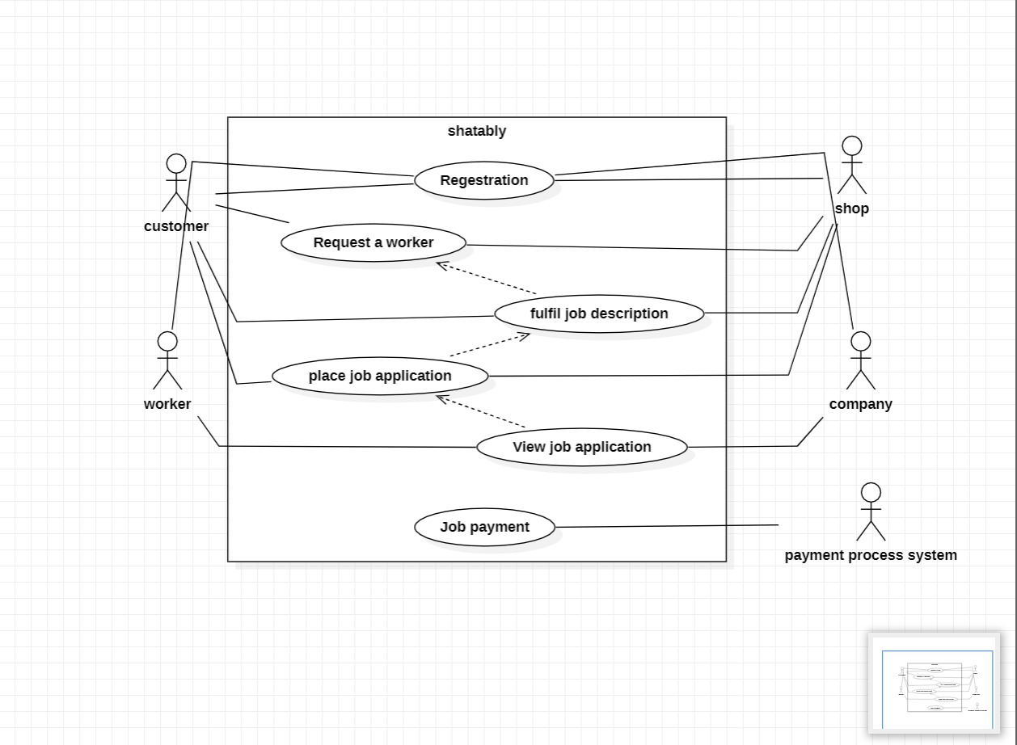

**4.2 Use Case [Store]**

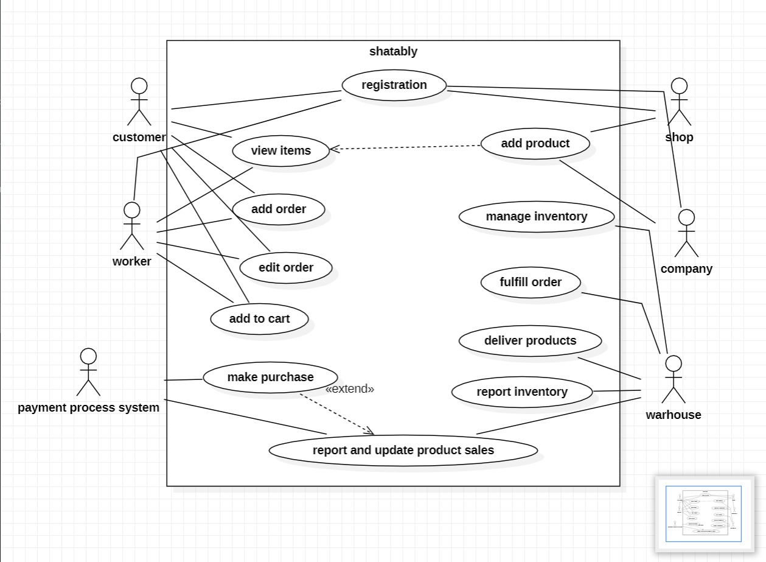A use case diagram is a graphical depiction of a user's possible interactions with a system. A use case diagram shows various use cases and different types of users the system has and will often be accompanied by other types of diagrams as well. The use cases are represented by either circles or ellipses.

1. **Activity Diagram**

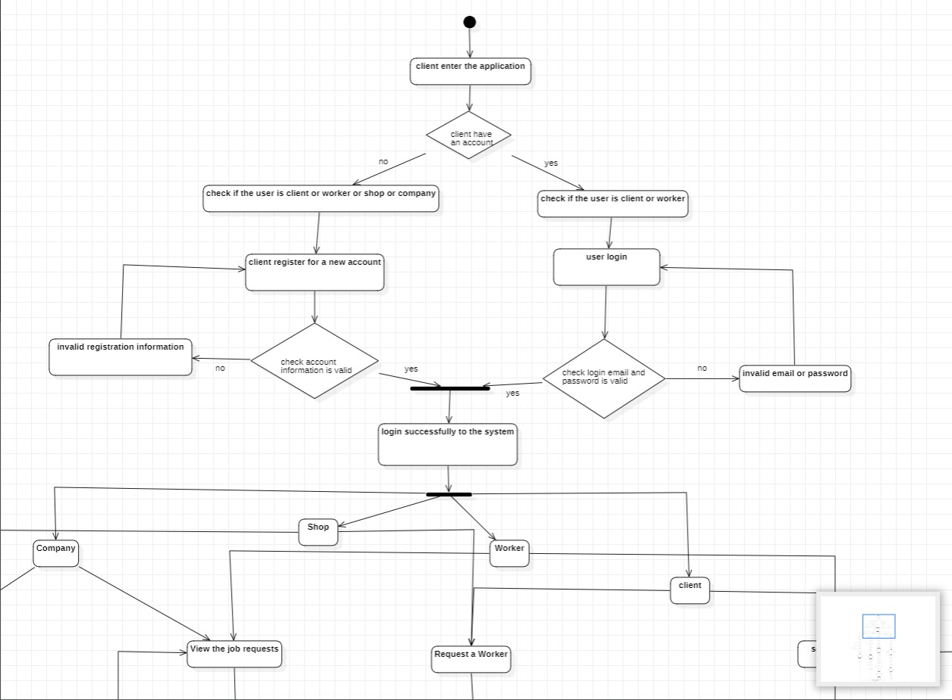An activity diagram visually presents a series of actions or flow of control in a system similar to a flowchart or a data flow diagram. Activity diagrams are often used in business process modeling. They can also describe the steps in a use case diagram. Activities modeled can be sequential and concurrent.

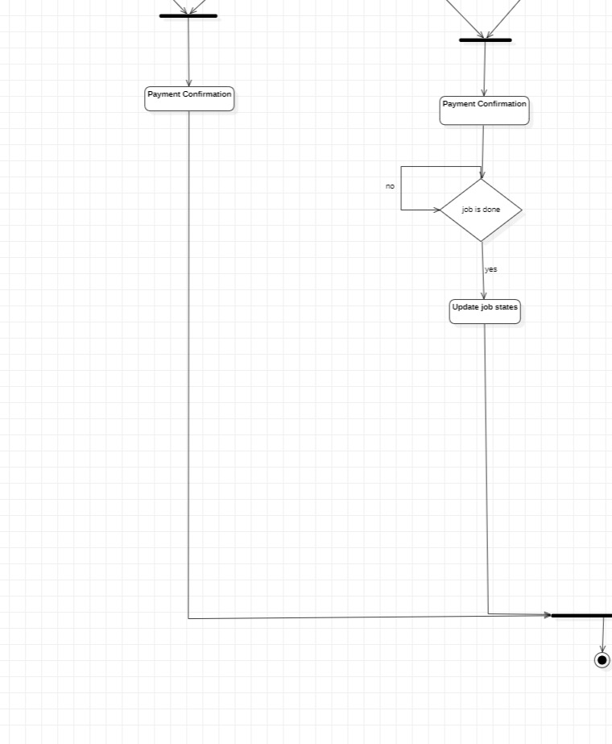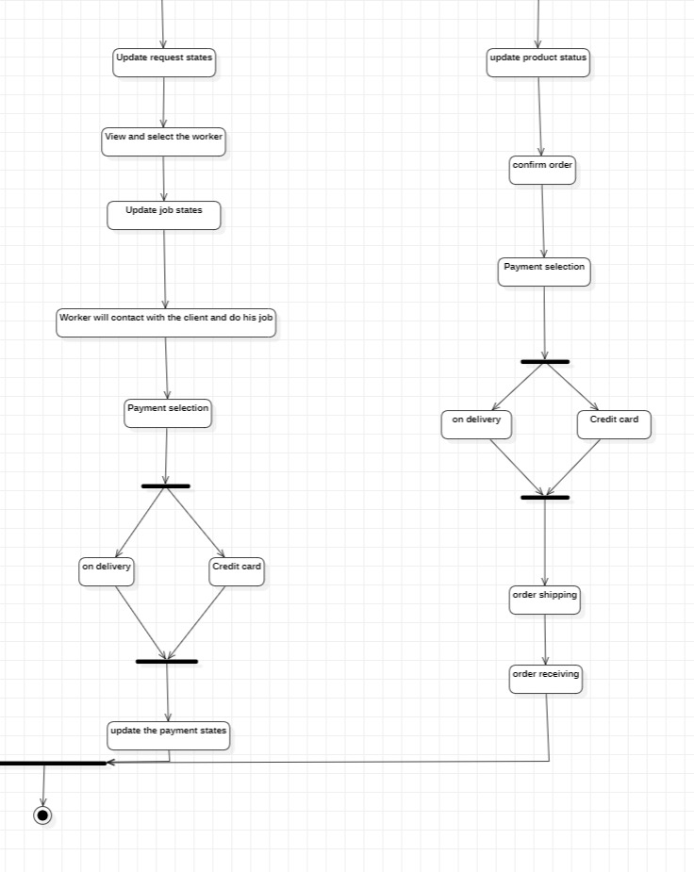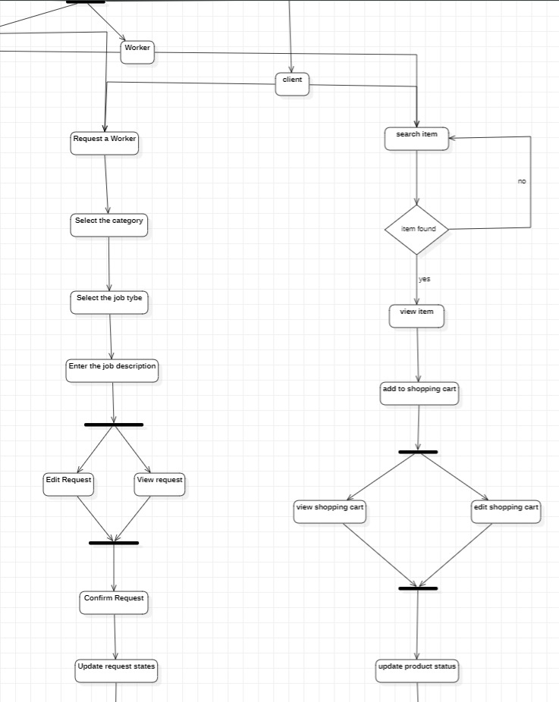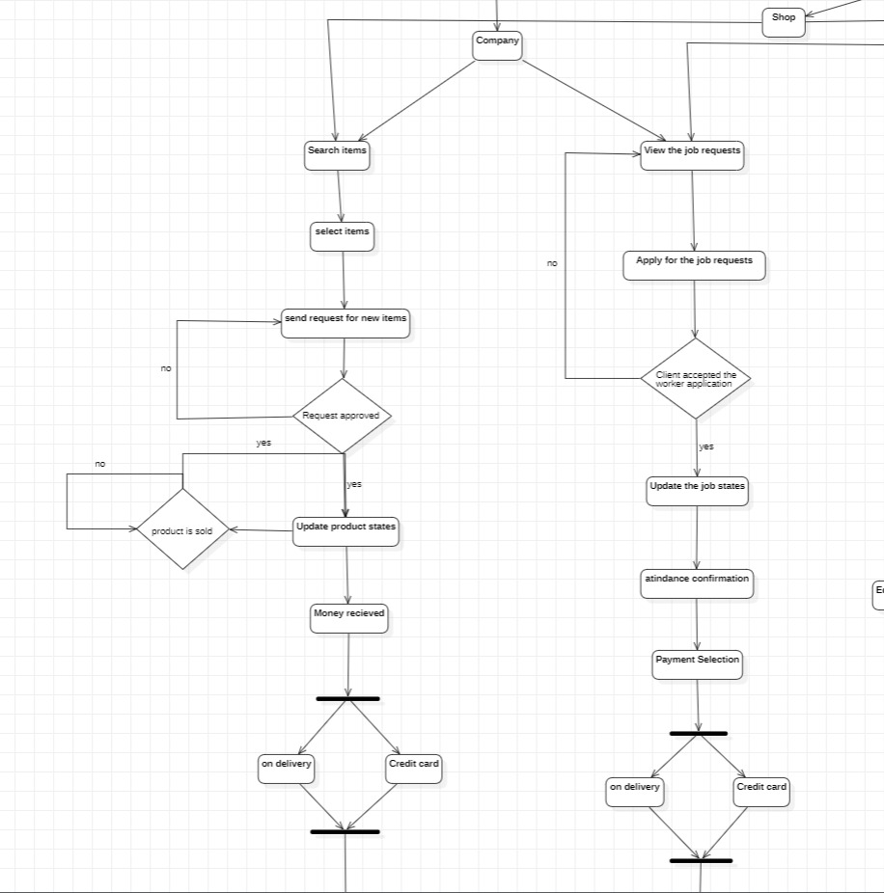

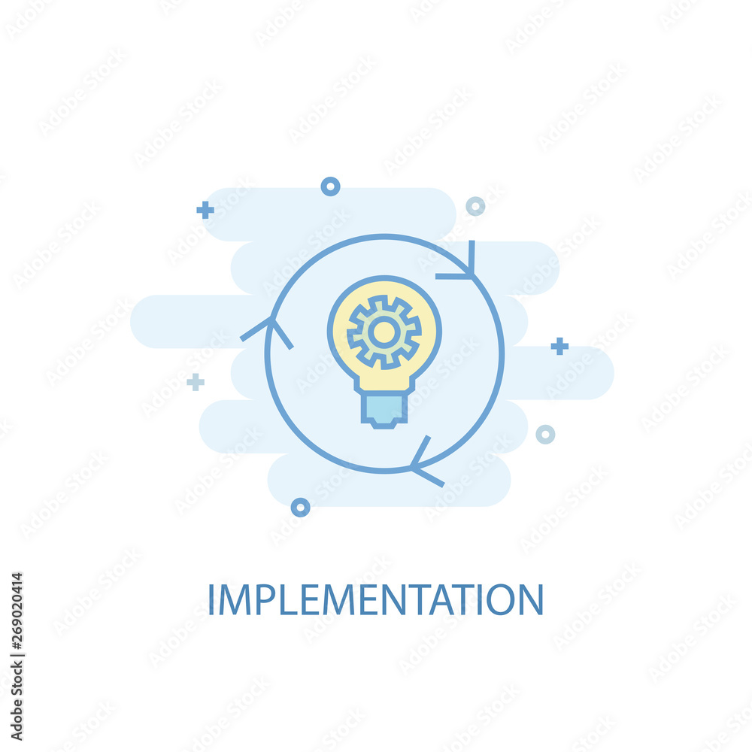

**Chapter 4**

**Design & System Implementation**

In this chapter, we will talk about the design and implementation of the system for this project.

1. **In the beginning** we used **Adobe XD** program to design the application **(Mobile Application & IOS & Web Site**) To make UI & UX.

* Web designs on Adobe XD.

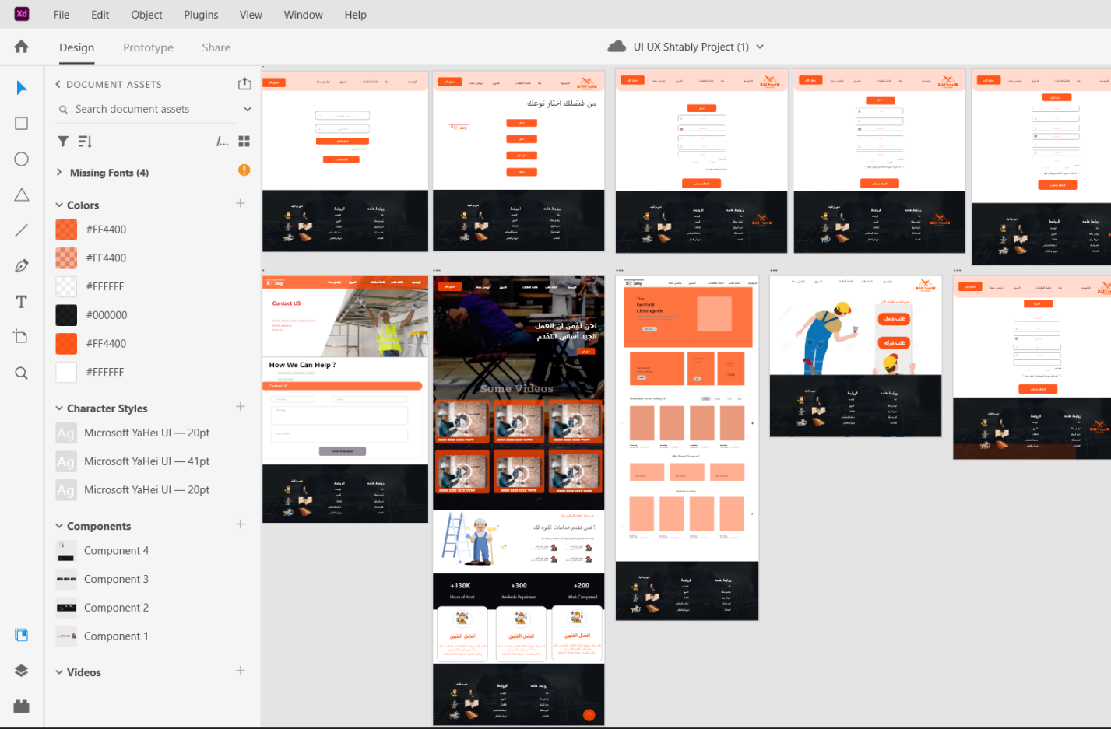

* Mobile application designs on Adobe XD [ Last Version] .

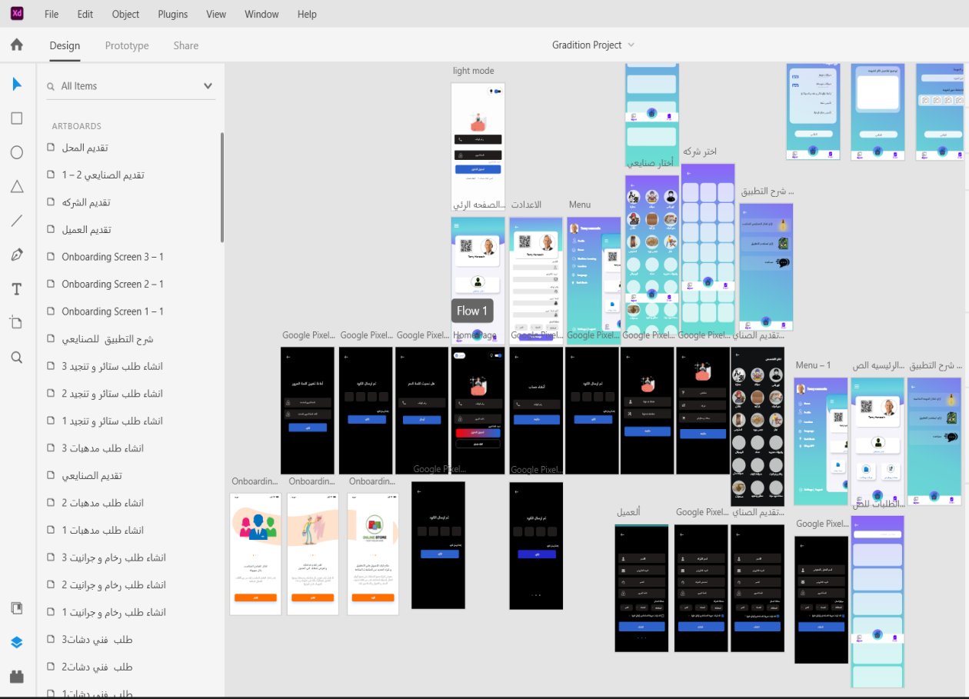

* 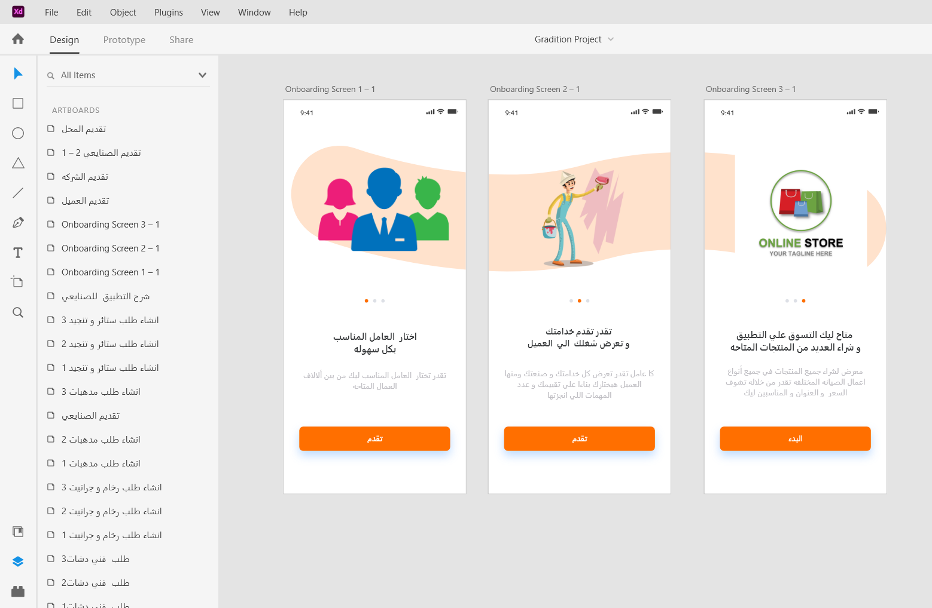On-Bording Screen In mobile App.

**2-How does the app work from start to finish?**

1. Design for Full Screen Activity (splash screen):

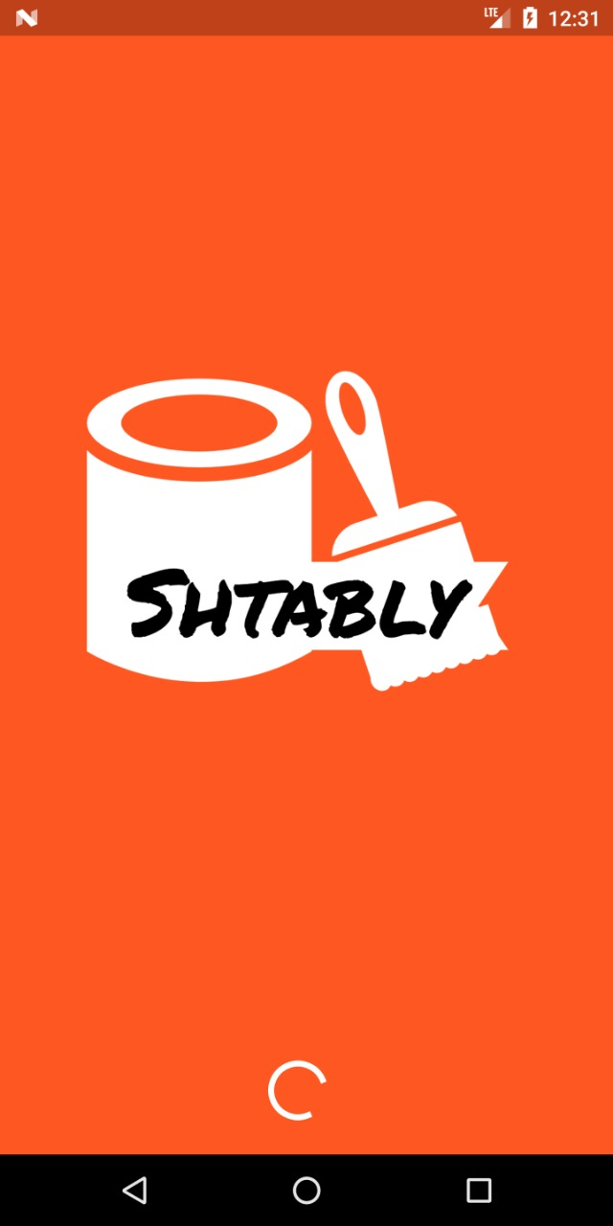This screen is designed as an opening screen for the

application, the application's logo is displayed, and

then it moves to the screen of Login Activity.

2. Design for Full Screen Activity (OnBordung Screen):

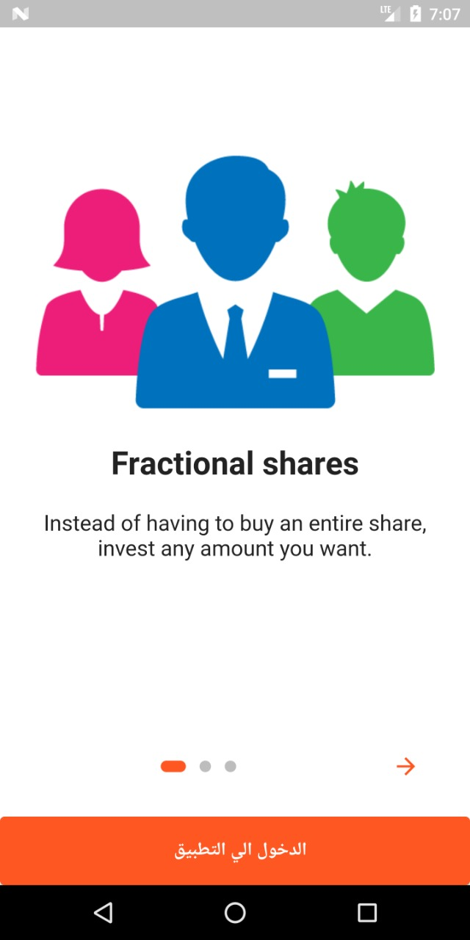

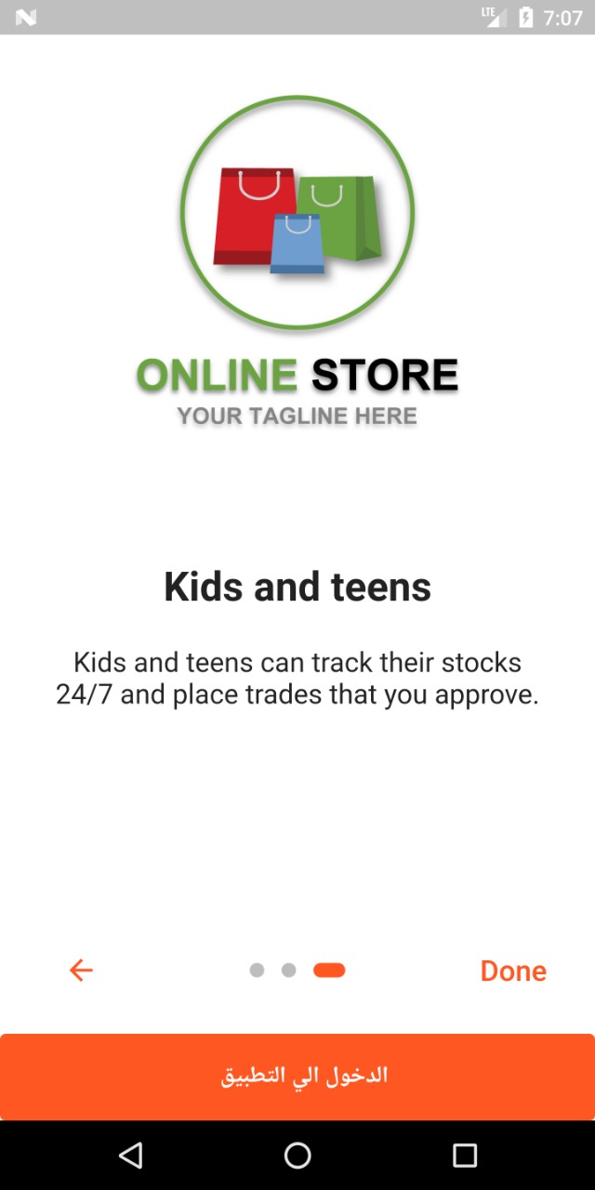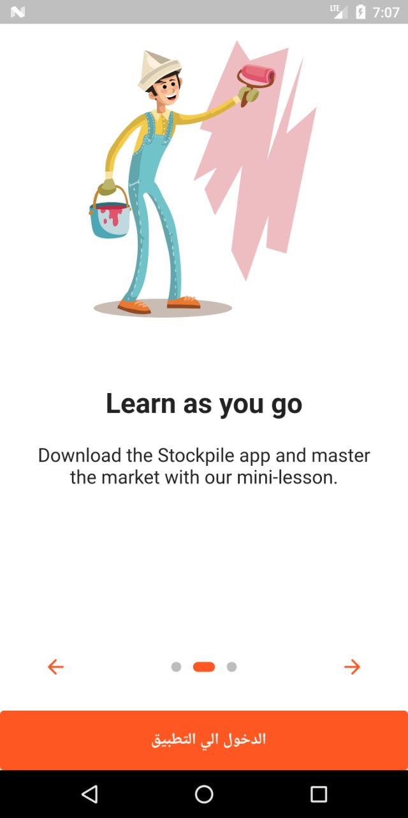

**What is Onboarding?**

## The onboarding process is essentially a series of screens which direct users through an app interface. These onboarding screens have three purposes:

1-Educate the user about the functions and benefits of the app,

2-Allow the user to register their login details.

3. Design for Login Activity:

A [ Login ]

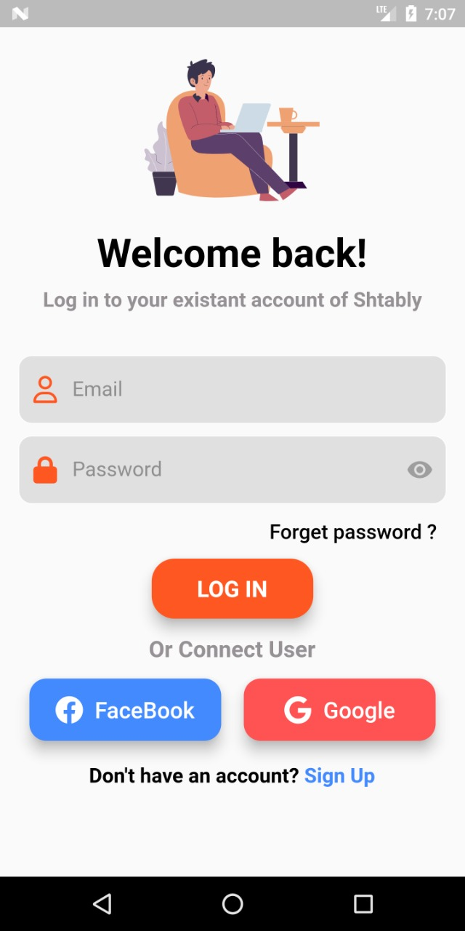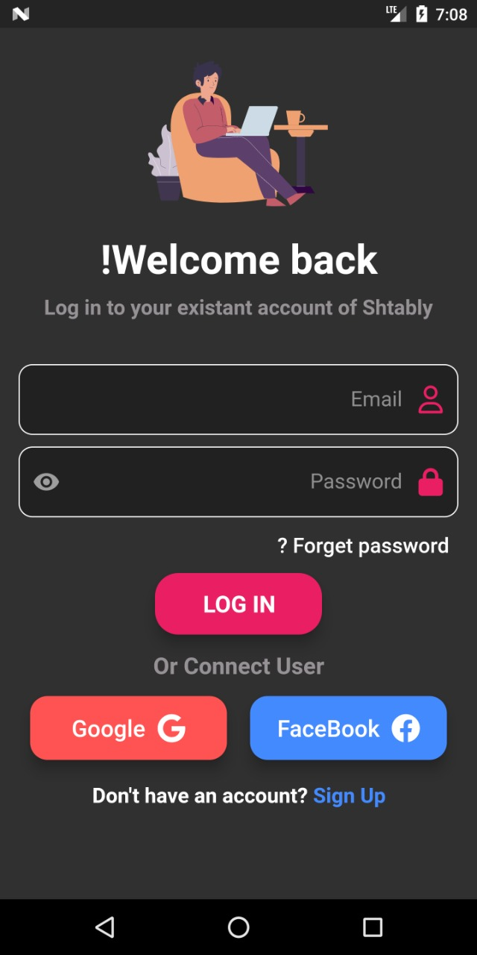The "login" screen is designed as a main screen, the user enters our registered email and password, and then presses the button "Login In" to move to a screen "main user" but if he does not have an email on The application presses the button "Sign Up" And if it has an email, but losing its password is set to "Forget Password",Also, log in with Facebook or Google +.

**B** [Forget Password]

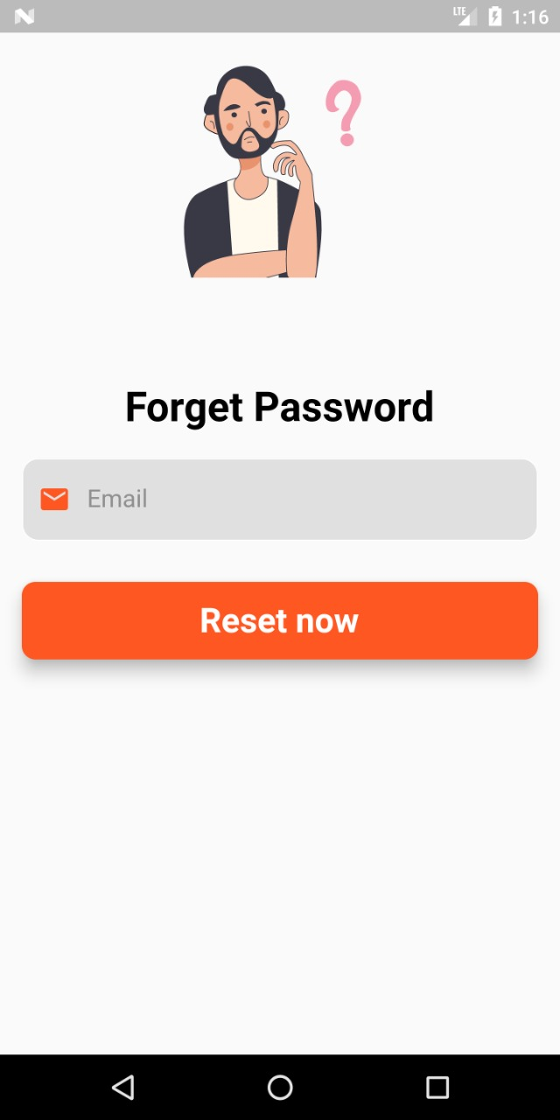

If it has an email, but losing its password is set to

"Forget Password" a screen will appear “Forget

Password” he will enter his registered email and the

password will be retrieved again.

C. Design for Registration Activity:

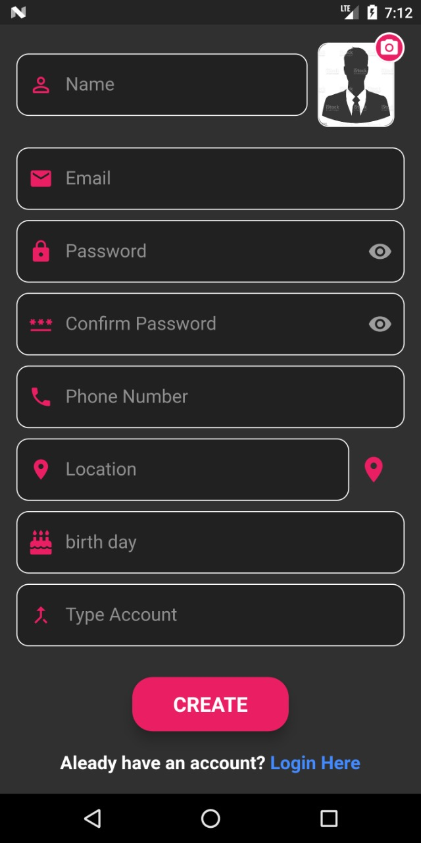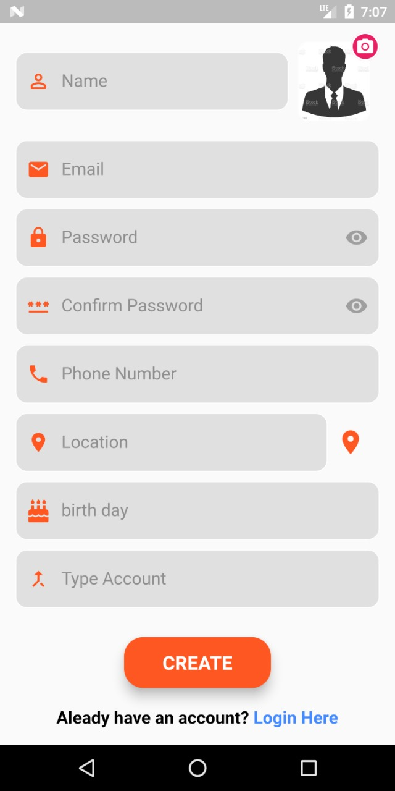The design of this screen was made to us on a table “Users” in the database, where it was designed so that the user can enter his data and register in the application and use it. Through which the user can enter:-[ Name - Email - Password - Phone Number - Location - Brithday - Type Account ]

D.Design for Map Activity:-

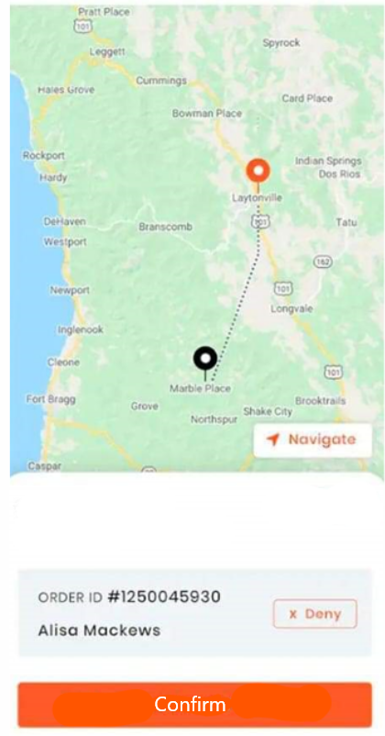

**Through the screen Map can specify the user's**

**address and store it in its data base when registering**

**in the application.**

E. Design for Shop [ Home ] Activity:-

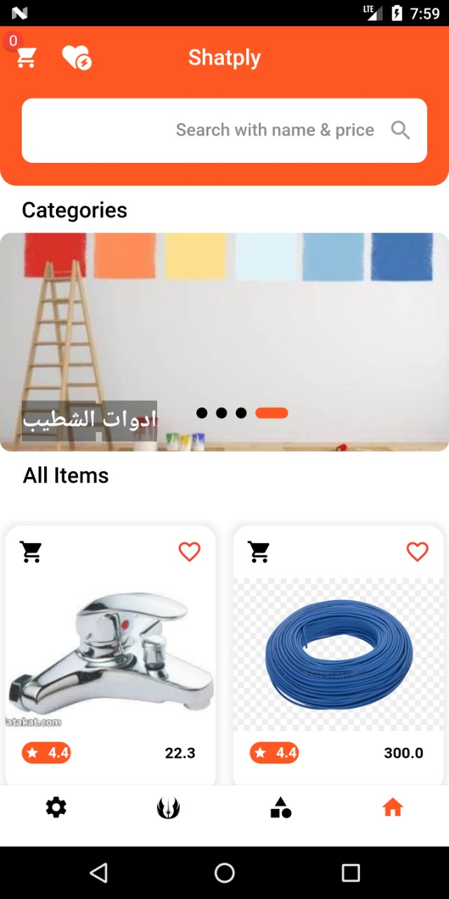

**On this screen, you can shop on the application and buy as many products as you need, and you can add products to favorites or Cart Item .**

F. Design for Product details Activity:-

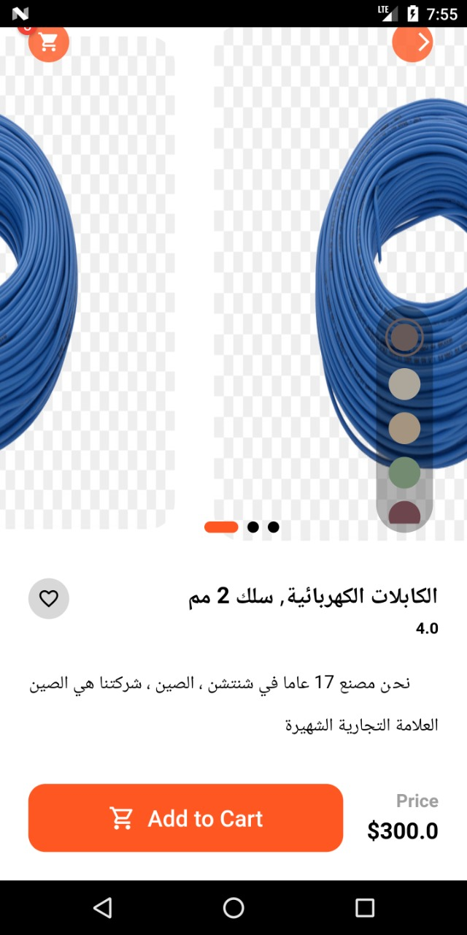

On this screen, the details of the products are displayed, including the price, a brief summary, and the completion of the purchase process

G. Design for Cart Items Activity:-

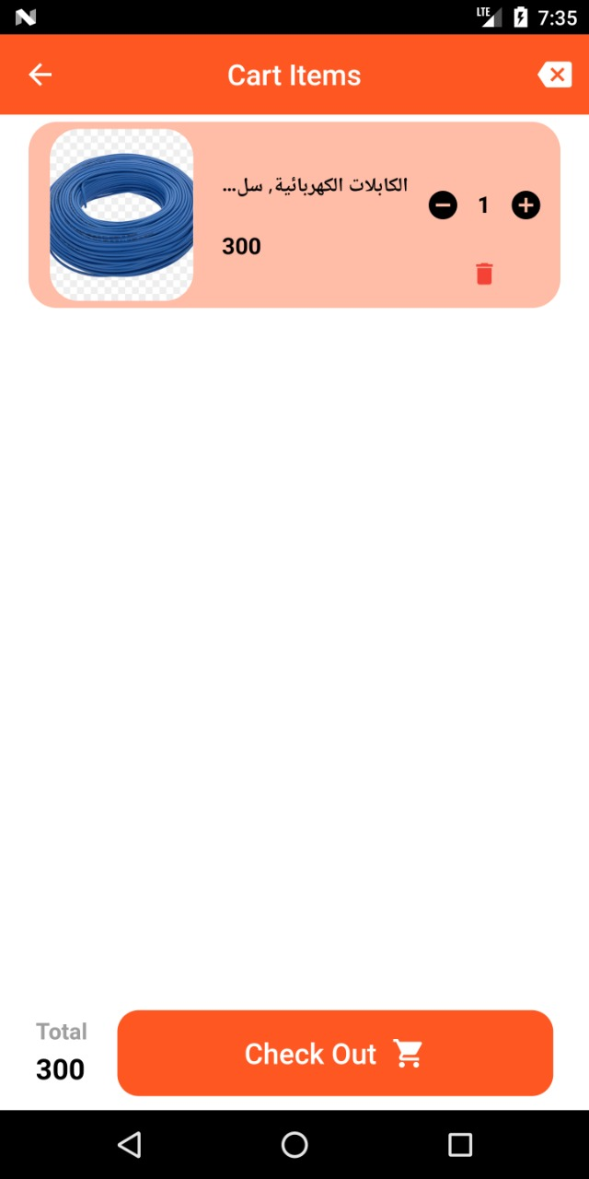

In this screen, products are bundled before purchases are made

H. Design for Payment Activity:-

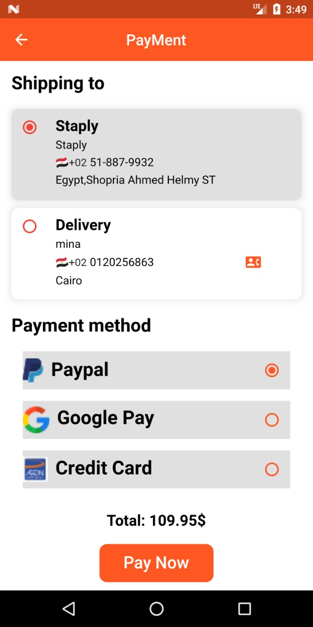

On this screen, you can choose the payment method to complete the purchase of products from the store.

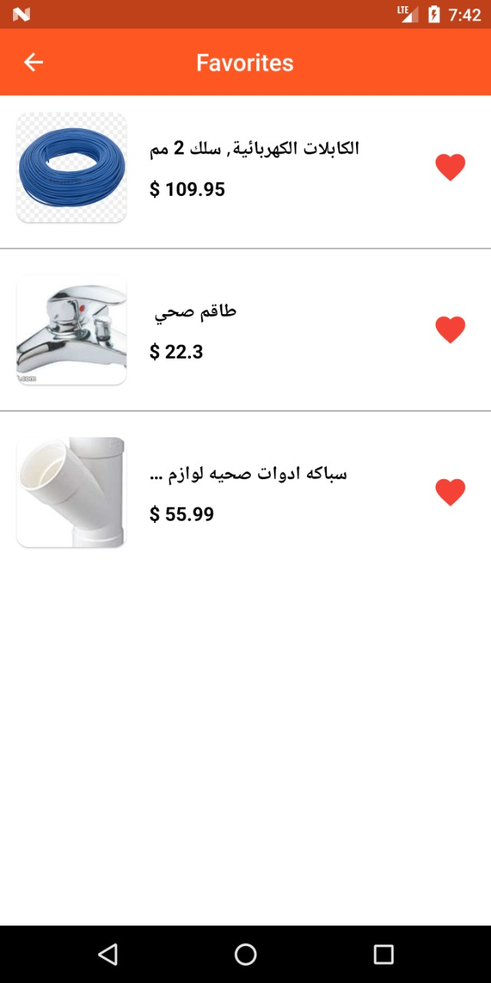I. Design for Favourite Activity:-

On this screen, you can group the products that you have added to this page

J. Design for Create Order Activity:-

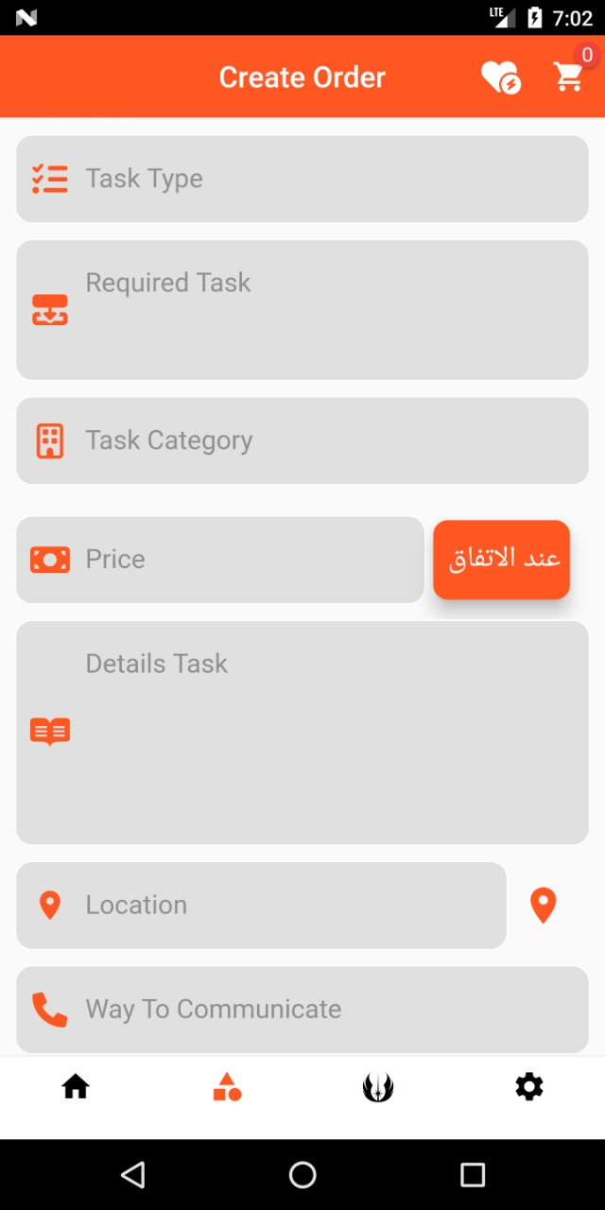

**On this screen, you can create a maintenance request and a worker request using the following information .**

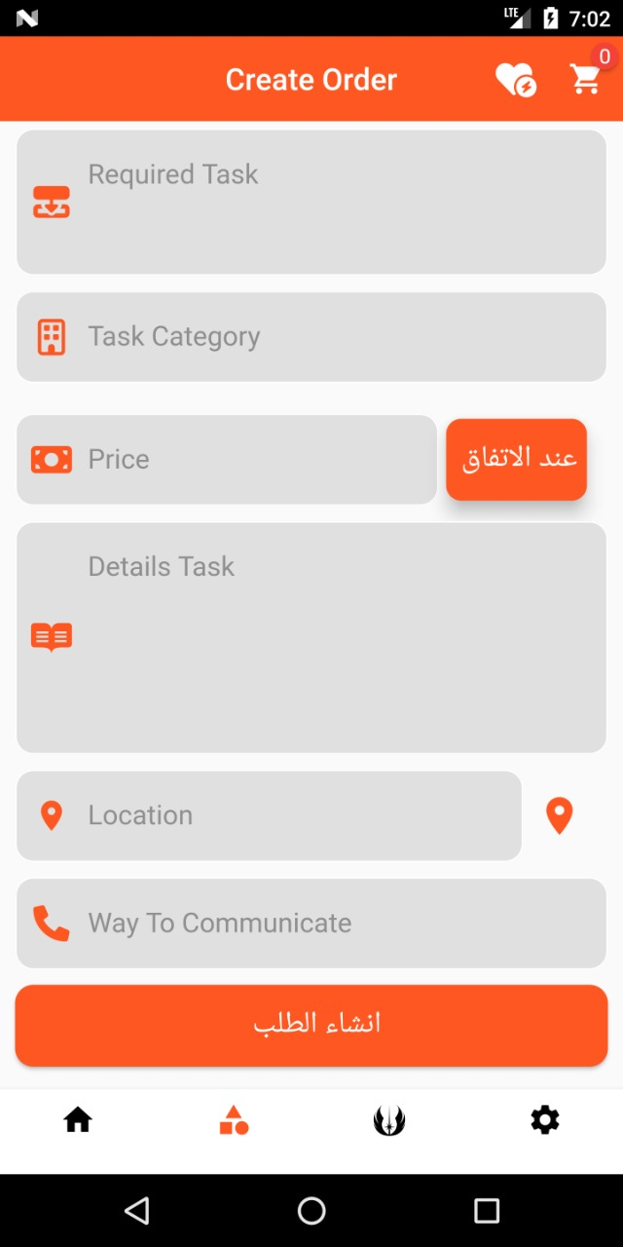

K. Design for Orders Activity:-

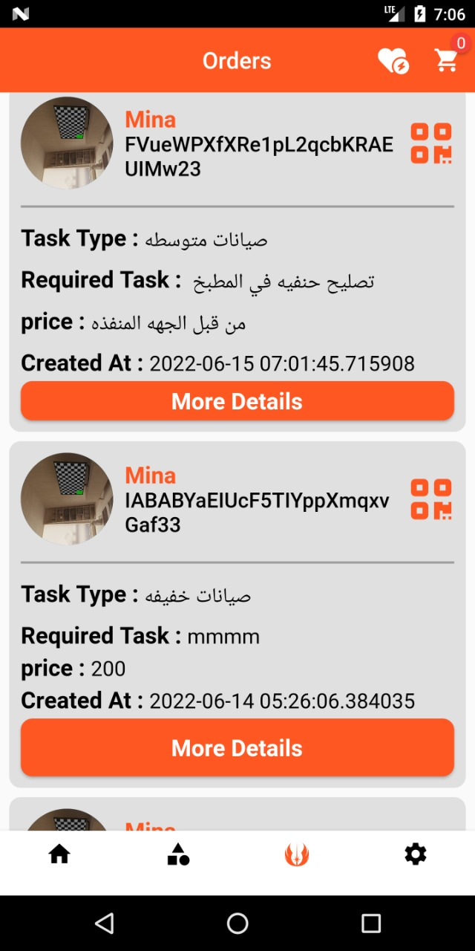**On this screen, the pending orders that you created on the previous page are displayed**

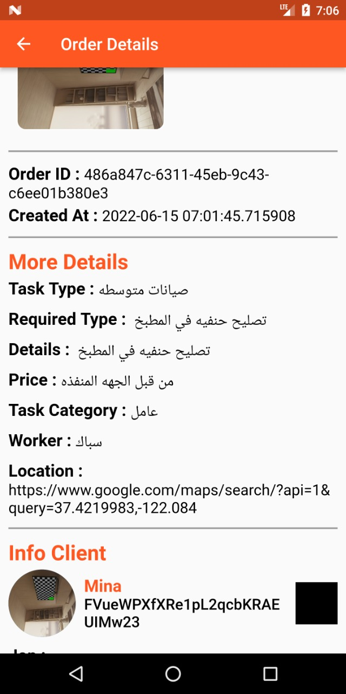L. Design for Orders Details Activity:-

**On this screen, the details of each of the requests that have entered the information for each of them are displayed**

M. Design for Settings Activity:-

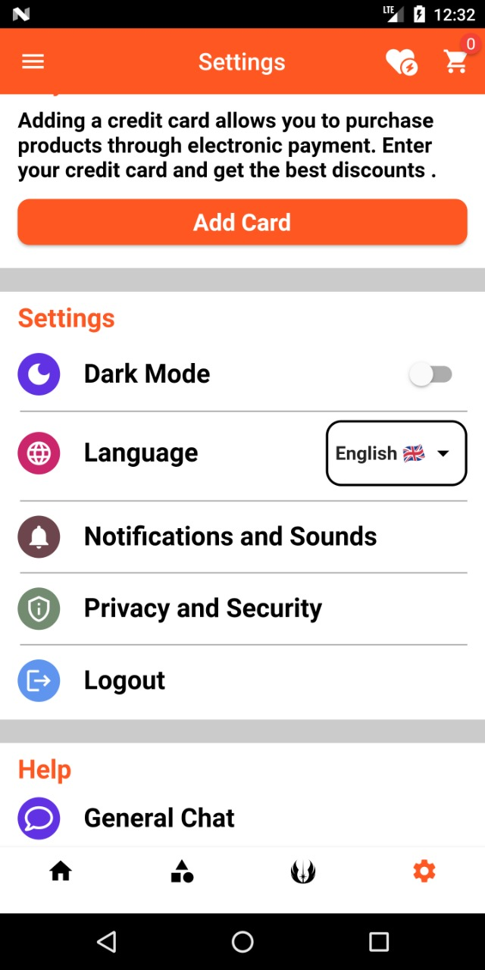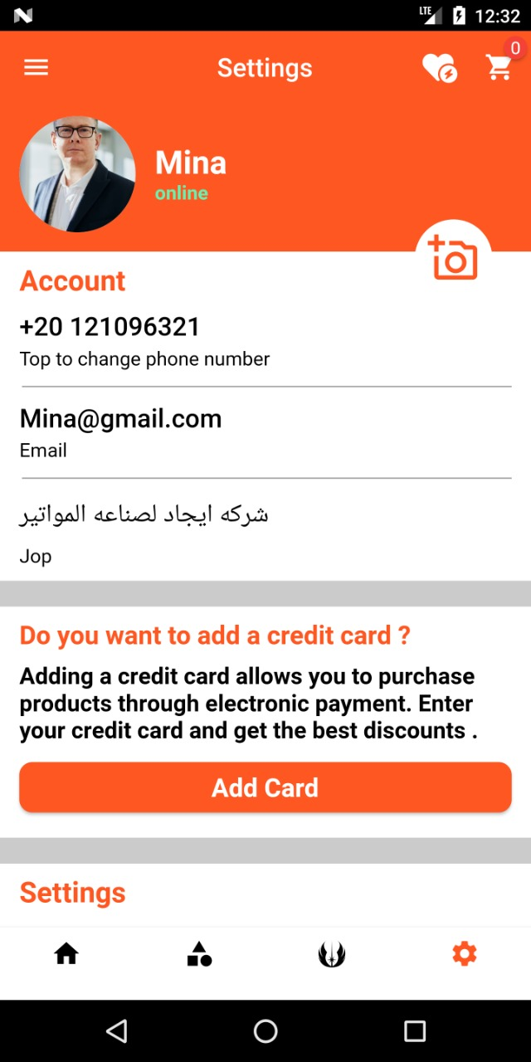

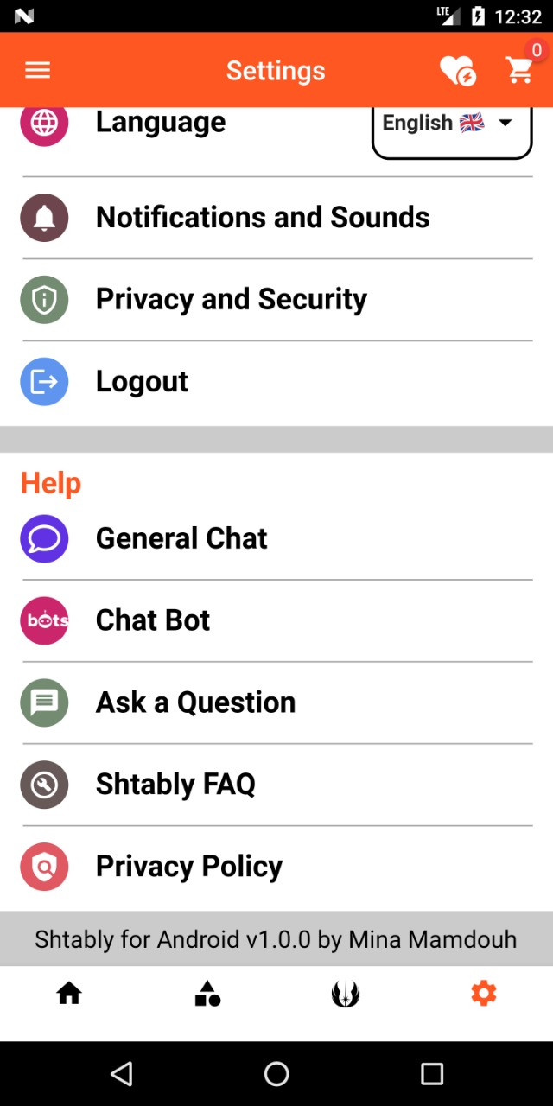

**The settings page is where personal information and some other features are modified**

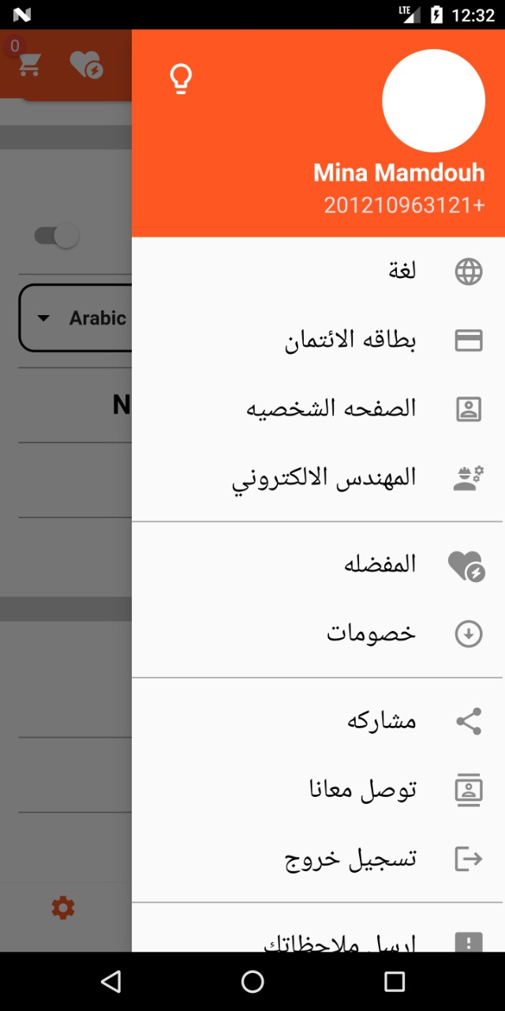N. Design for Drawer Activity:-

O. Design for electronic engineer Activity:-

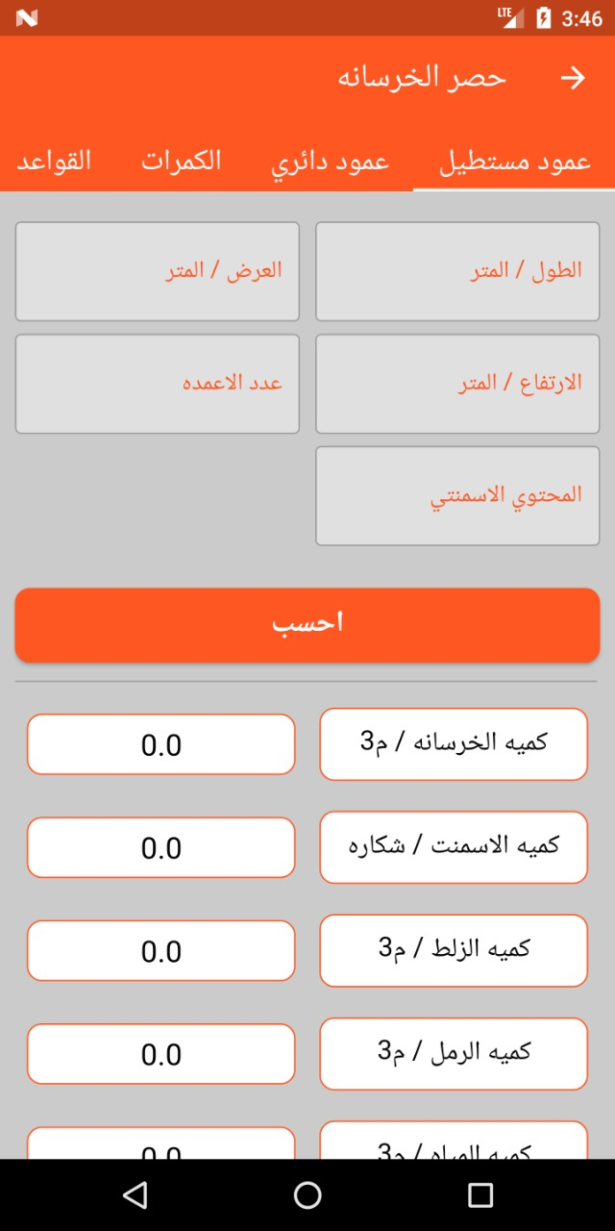

**On this page, you can calculate some of the engineer’s operations by entering some numbers and he will calculate one of the operations above.**

**2-How does the Web site work ?**



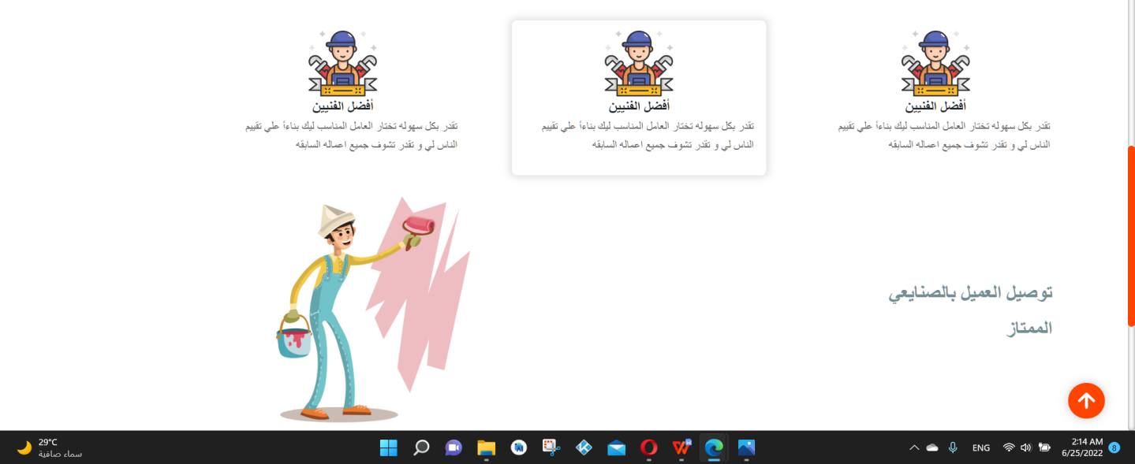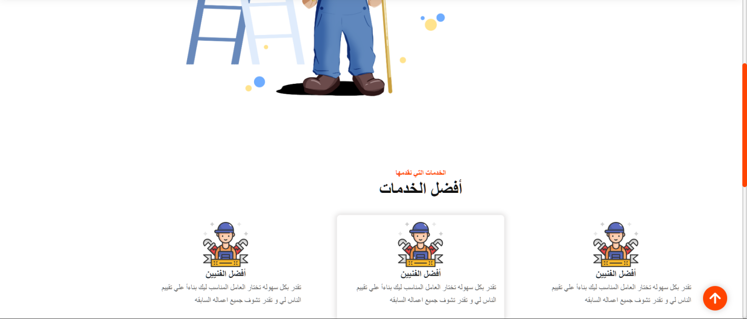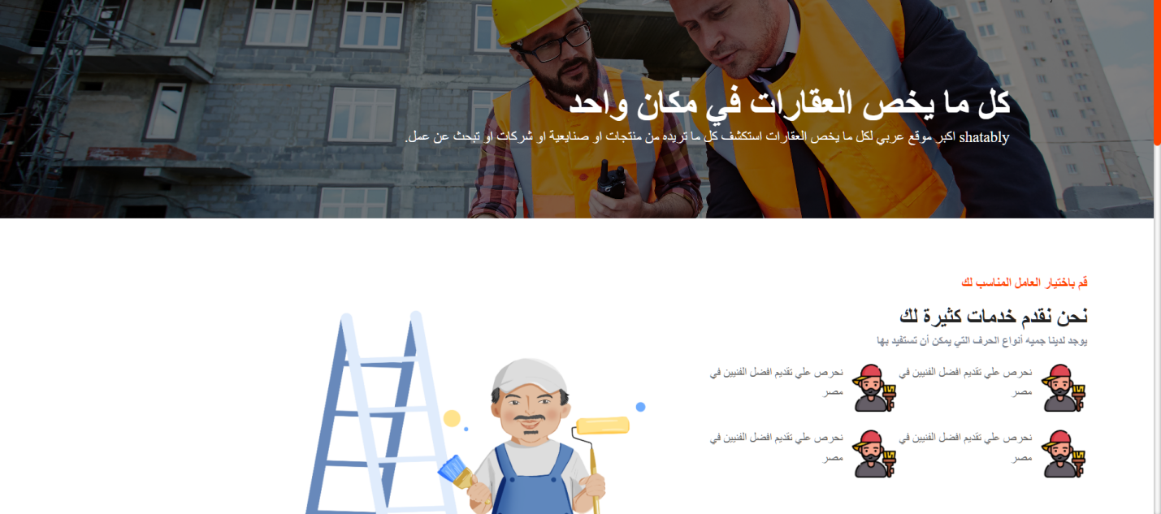 Figure1 Home Page

**Create Work Order**

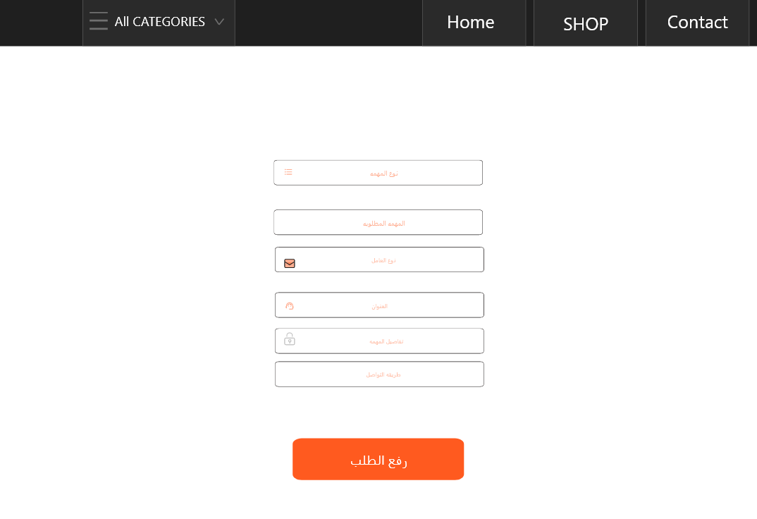

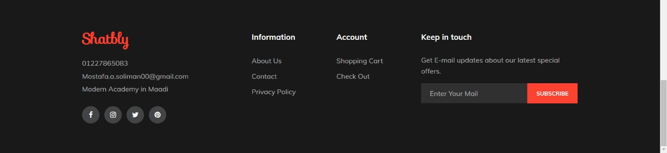

**Store Page**

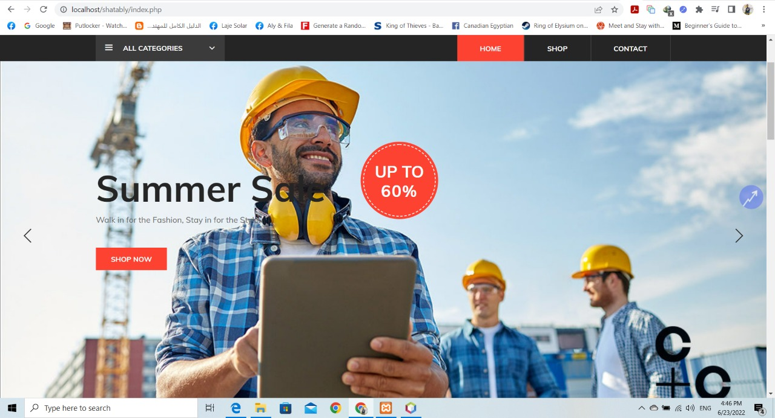

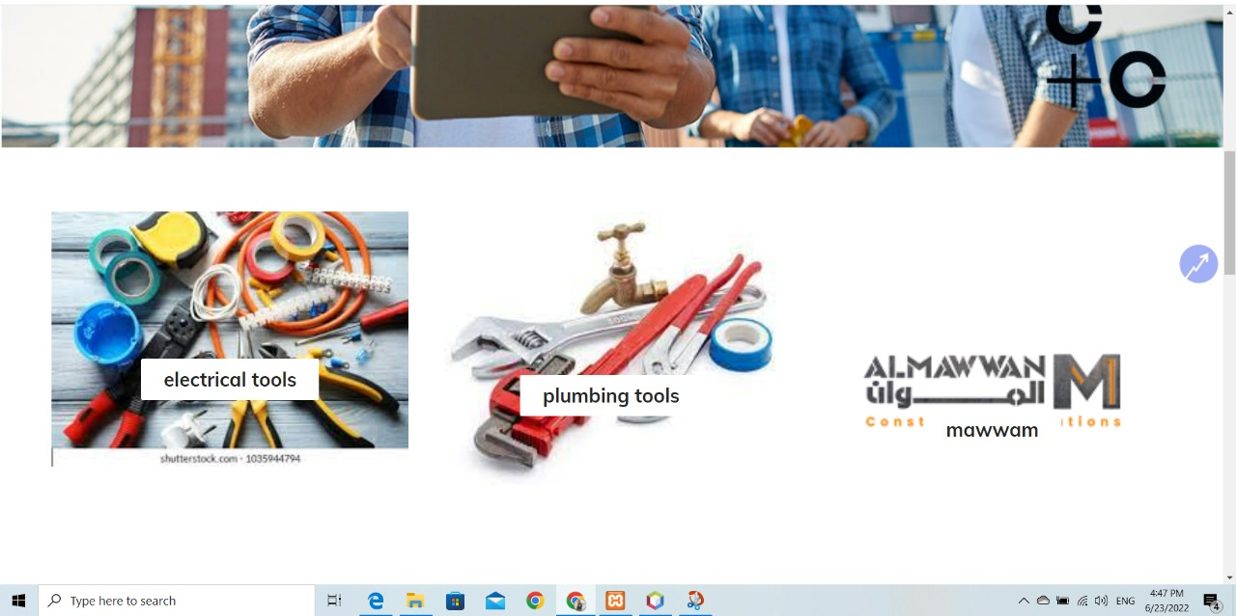

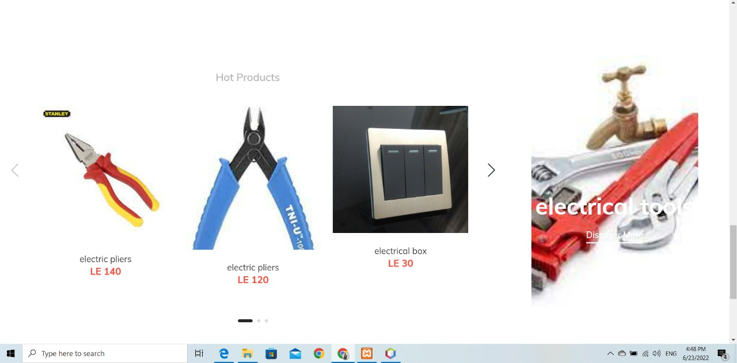

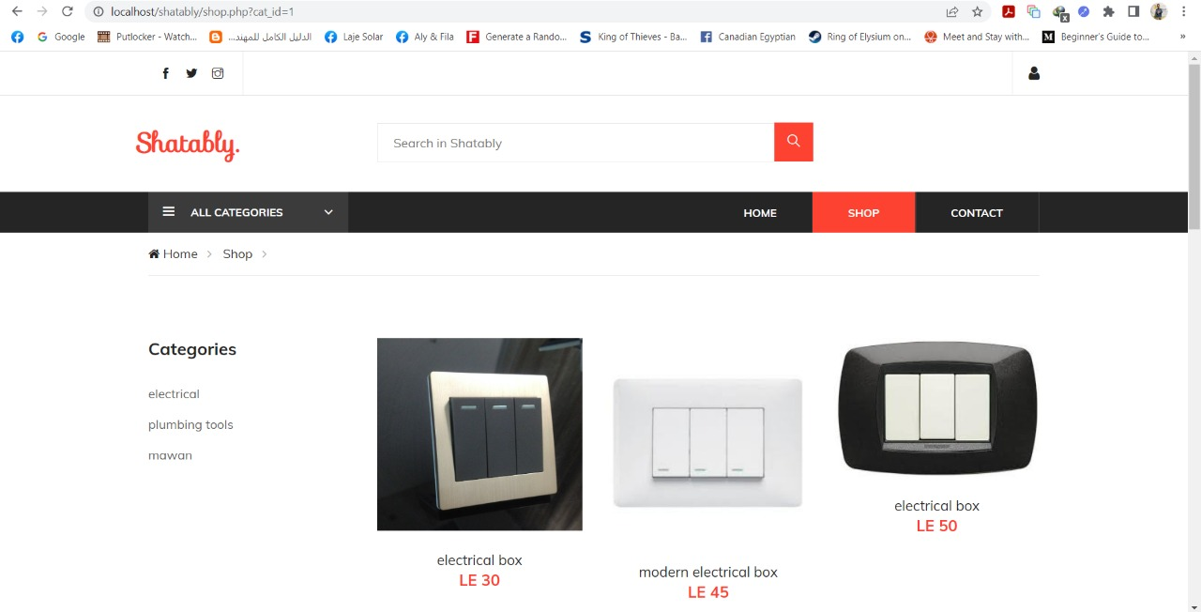

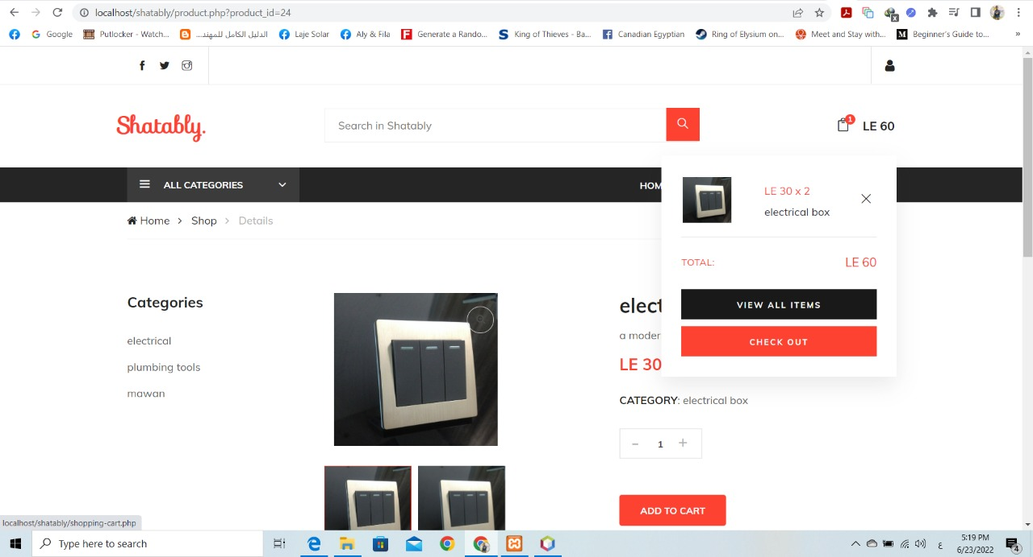**Product Page**

**Check Out**

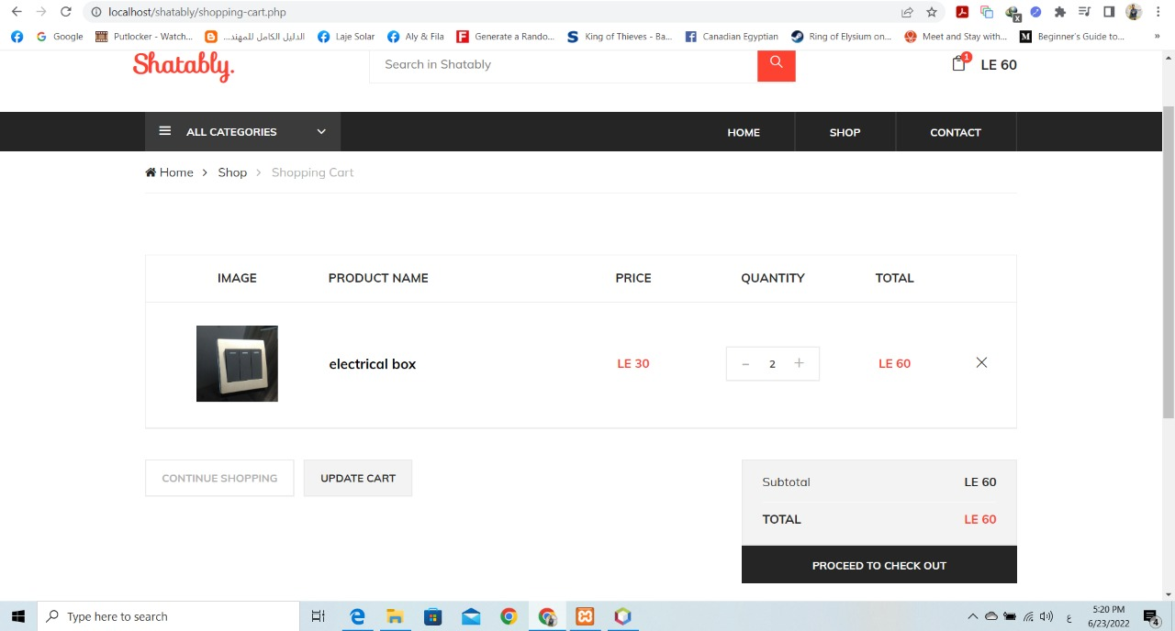

**Shop Home Page**



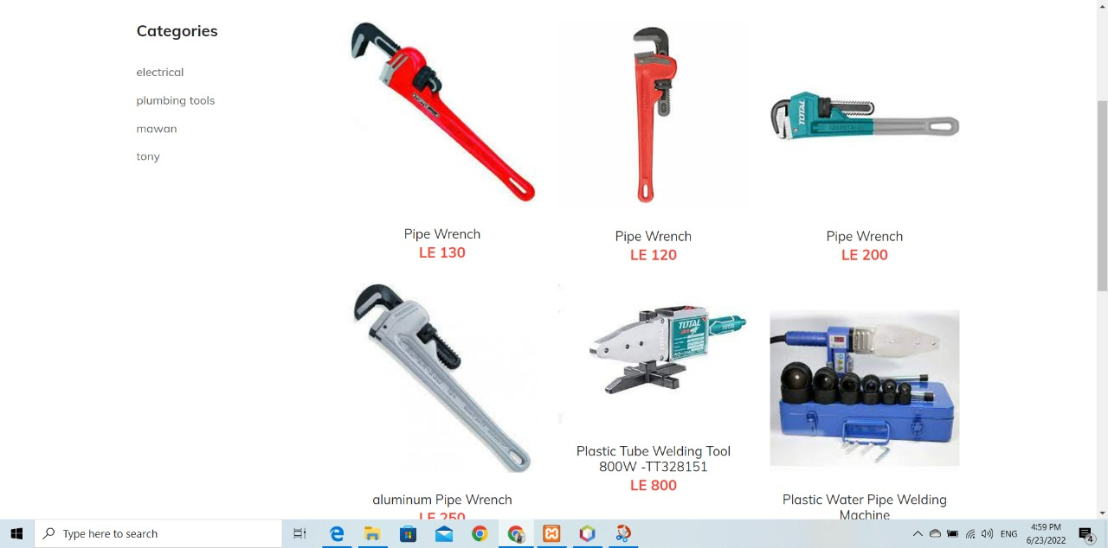

**Contacts US**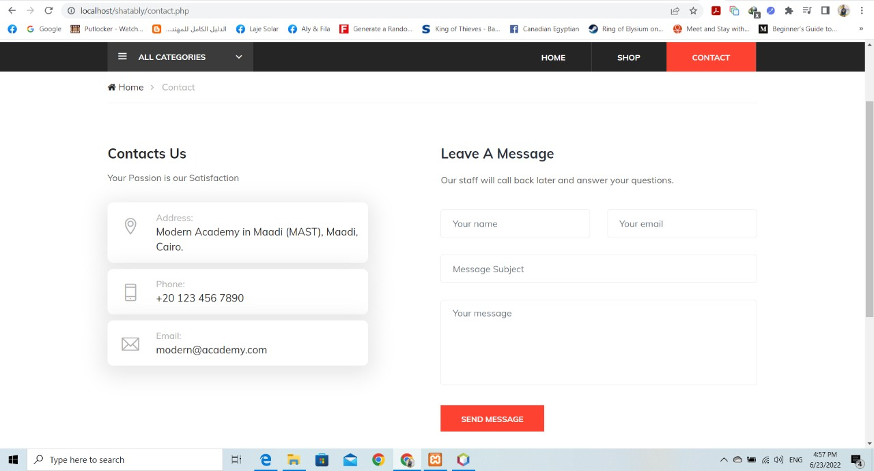

Implementation

1. 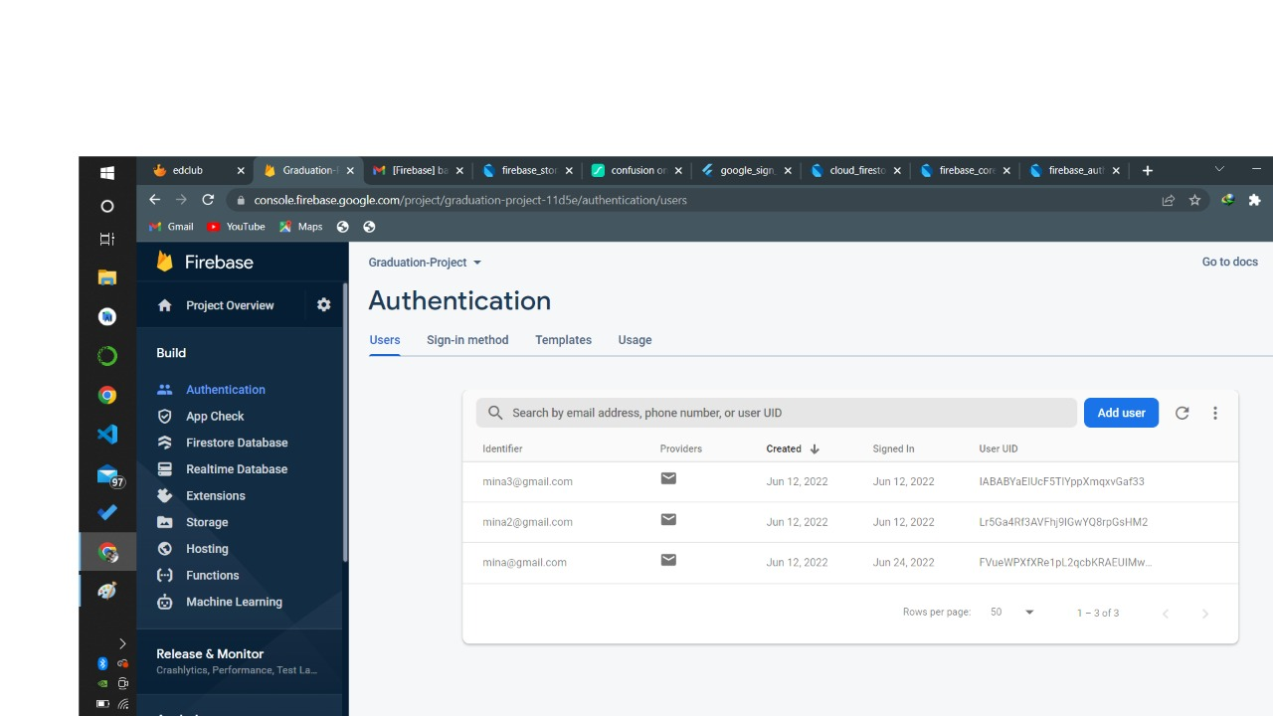Authentication



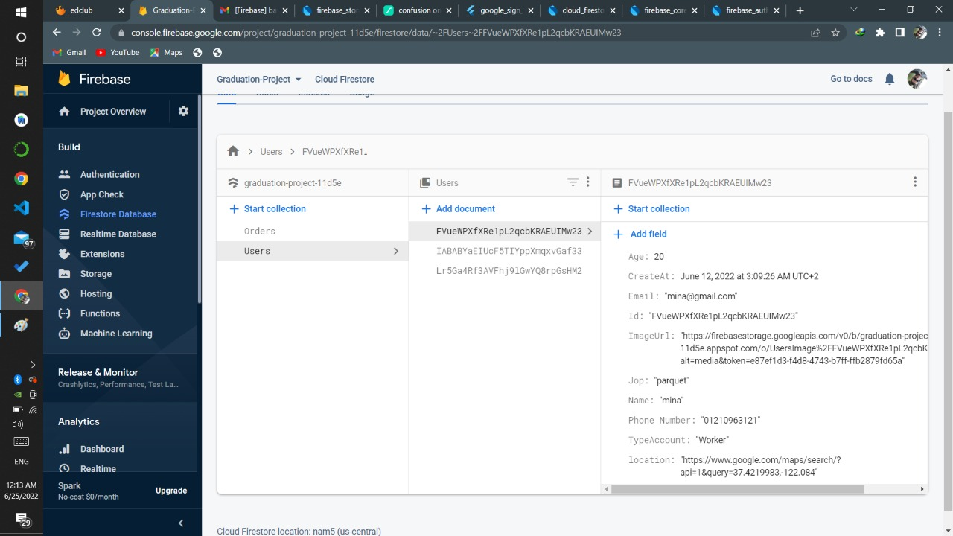2-Firebase database [Users]

]

3-Firebase data base [Orders]

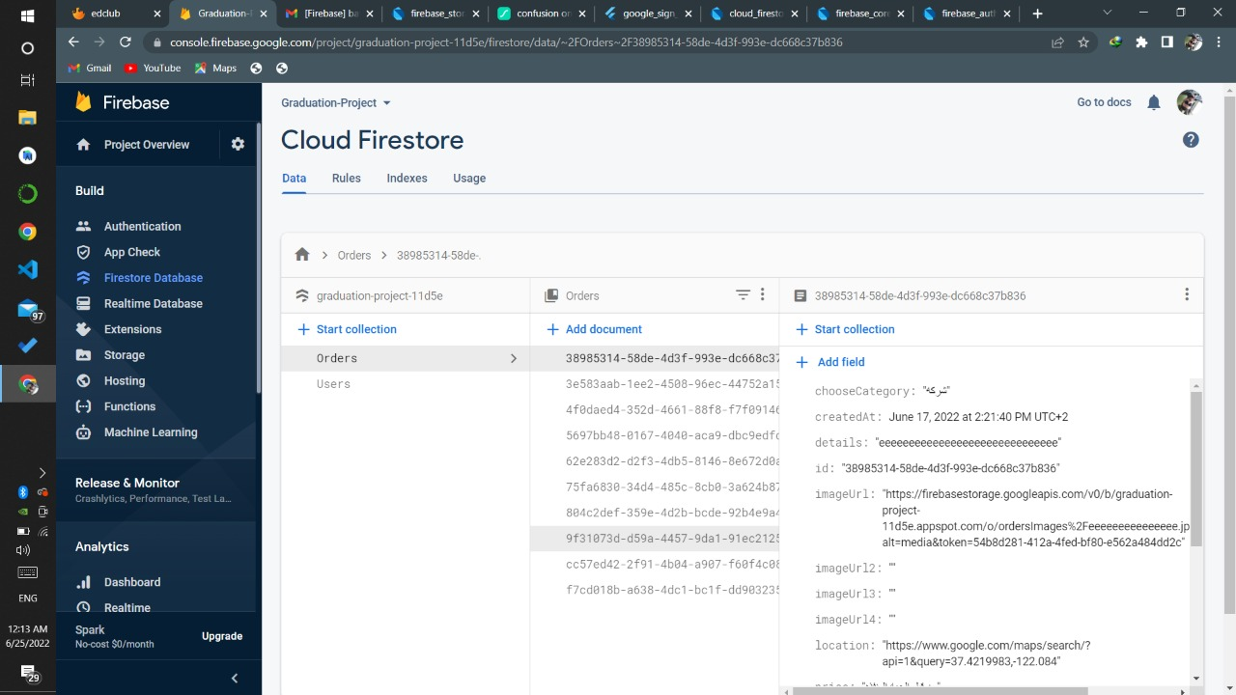

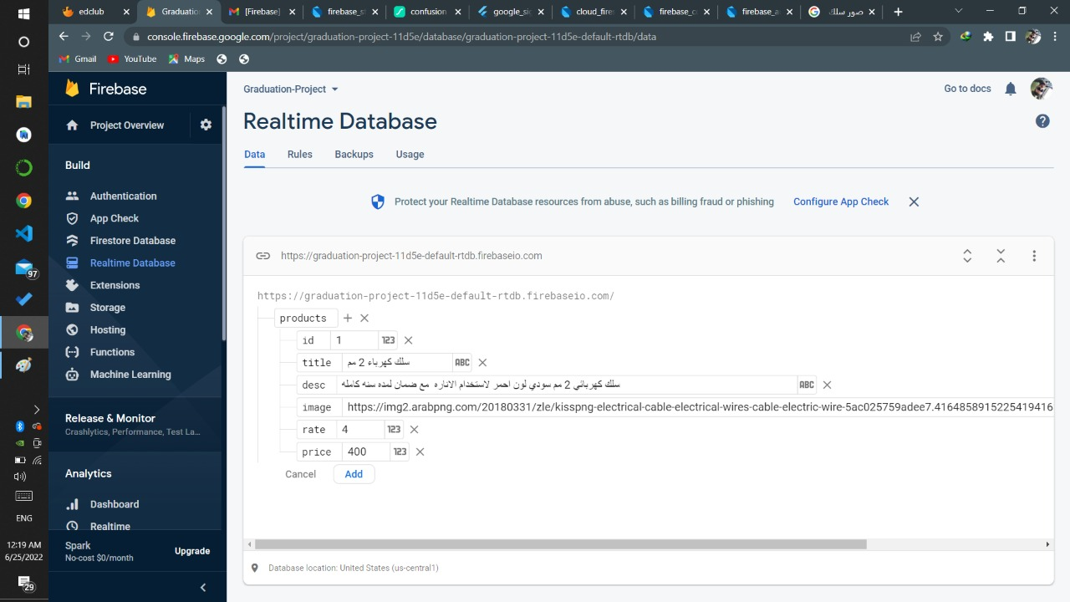4-Realtime Data base

5-Storage

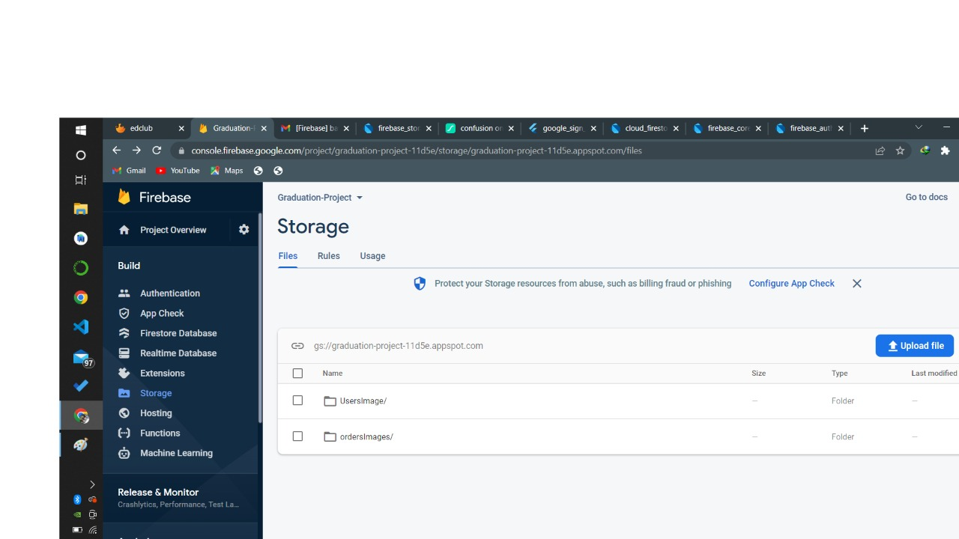

**Chapter 5**

**Tools**

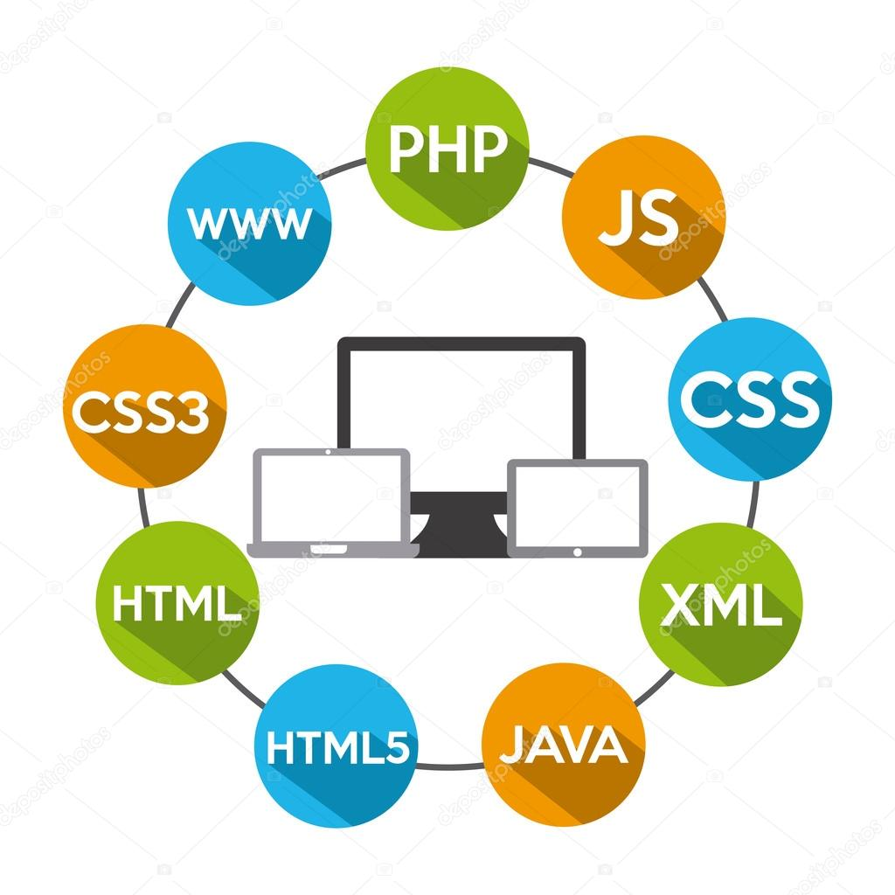

****In this chapter, we review all the tools that we used to create and build this application, from the design stage to the end.

1. **Adobe XD From UI & UX :-**

Adobe XD is a vector-based UI and UX design tool and it can be used to design anything from smartwatch apps to fully fledged websites. Let’s take a look at what it offers designers and why it’s become such a powerful tool in the web design industry.

### **What is Adobe XD Used For?**

What’s important to remember is that Adobe XD addresses the two main problems Photo shop and other graphics applications couldn’t:

1. Interaction design isn’t static. A designer cannot communicate a fluid and dynamic design using pixels alone.
2. A modern design process involves more than a polished finished article. Wire-framing, iteration, and behavior are all part of the collaborative decision making with UI and UX design.

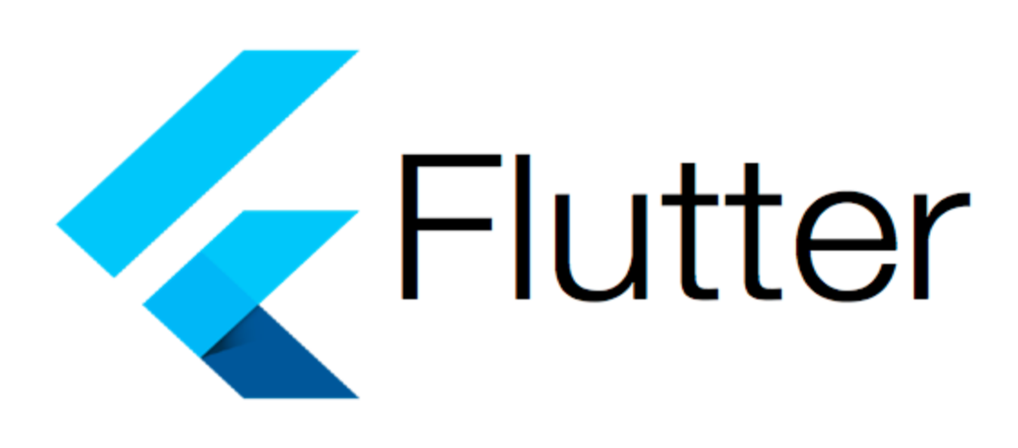

**2-Flutter From Mobile Application {Android & IOS} .**

**In general, creating a mobile application is a difficult and time-consuming operation. A mobile application can be built using a variety of frameworks. Android has a native framework based on the Java programming language, while iOS has a native framework based on the Objective-C / Swift programming language.**

**However, we must code in two distinct languages and use two different frameworks to construct an application that supports both OS. There are mobile frameworks that support both OSes to aid with this complication. These frameworks range in complexity from simple HTML-based hybrid mobile application frameworks (which use HTML for the user interface and JavaScript for the application logic) to complicated language-specific frameworks (which do the heavy lifting of converting code to native code). Regardless of how simple or complex they are, these frameworks always have a number of drawbacks.**

## **Features of Flutter :-**

**Flutter framework offers the following features to developers**

**Modern and reactive framework.**

* **Uses Dart programming language and it is very easy to learn.**
* **Fast development.**
* **Beautiful and fluid user interfaces.**
* **Huge widget catalog.**
* **Runs same UI for multiple platforms.**
* **High performance application.**

## **Advantages of Flutter :-**

* Because of its simplicity, Flutter is a strong contender for rapid development. Its flexibility to be customize and extended makes it even more powerful.
* Developers have complete control over the widgets and their layout with Flutter.
* Flutter provides excellent developer tools, including a fantastic hot reload feature
* Flutter needs lesser testing. Because of its single code base, it is sufficient if we write automated tests once for both the platforms.
* **Disadvantages of Flutter :-**
* Because it is written in the Dart programming language, a developer will have to learn a new language (though it is easy to learn).
* Modern frameworks try to keep logic and UI as separate as possible, yet in Flutter, the two are merged together. We can get around this by using clever coding and high-level modules to segregate the user interface from the functionality.
* Flutter is another another framework for developing mobile apps. Developers are having a difficult time deciding which development tools to use in this crowded market.



**3-FireBase[Back End] .**



**What is Firebase ?**

Firebase is an app development platform that helps you build and grow apps and games users love. Backed by Google and trusted by millions of businesses around the world.

**how it works?**

The Firebase Realtime Database lets you build rich, collaborative applications by allowing secure access to the database directly from client-side code. Data is persisted locally, and even while offline, realtime events continue to fire, giving the end user a responsive experience.

## 1-**Authentication state**

Firebase Auth provides many methods and utilities for enabling you to integrate secure authentication into your new or existing Flutter application. In many cases, you will need to know about the authentication state of your user, such as whether they're logged in or logged out.

Firebase Auth enables you to subscribe in realtime to this state via a Stream. Once called, the stream provides an immediate event of the user's current authentication state, and then provides subsequent events whenever the authentication state changes.

1. Email & Password :-

This is the way to manually login to the Firebase.

B.Google:-

Login using G mail Account

C.Facebook:-

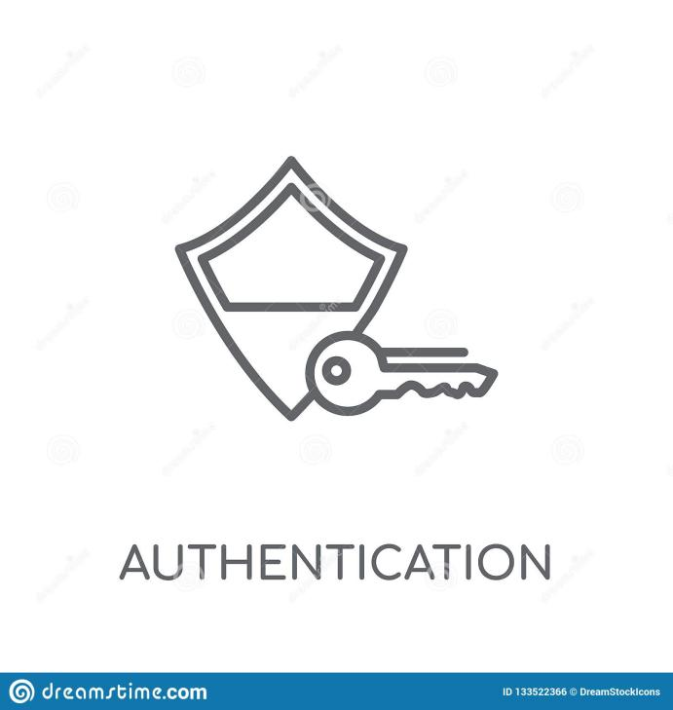login with Facebook using Facebook developer counsel service.

1. Phone Number:-

Credibility by sending an SMS message.

1. **Cloud Storage**

Cloud Storage for Firebase lets you upload and share user generated content, such as images and video, which allows you to build rich media content into your apps. Your data is stored in a [Google Cloud Storage](https://cloud.google.com/storage" \t "https://firebase.flutter.dev/docs/storage/_blank) bucket — an exabyte scale object storage solution with high availability and global redundancy. Cloud Storage for Firebase lets you securely upload these files directly from mobile devices and web browsers, handling spotty networks.

**3-Realtime Database**

A**.Navigate** to the Realtime Database section of the Firebase console. You'll be prompted to select an existing Firebase project. Follow the database creation workflow.

**B.Select a starting mode for your security rules:**

**Test mode**

Good for getting started with the mobile and web client libraries, but allows anyone to read and overwrite your data. After testing, make sure to review the Understand Firebase Realtime Database Rules section.

**Locked mode**

Denies all reads and writes from mobile and web clients. Your authenticated application servers can still access your database**.**

**4-Cloud Firestore**

Firestore is a flexible, scalable NoSQL cloud database to store and sync data. It keeps your data in sync across client apps through realtime listeners and offers offline support so you can build responsive apps that work regardless of network latency or Internet connectivity.

**5-Cloud Message**

Firebase Cloud Messaging (FCM) is a cross-platform messaging solution that lets you reliably send messages at no cost.‏

1. 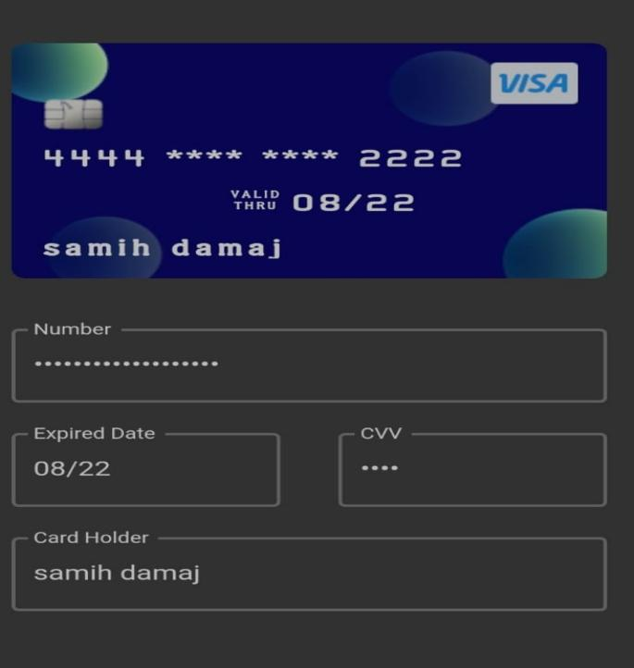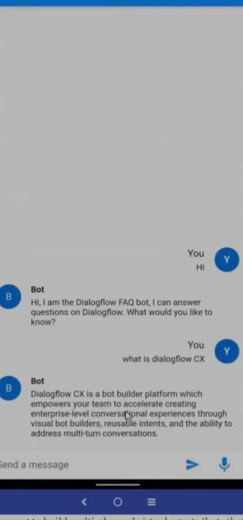**Machine Learning**

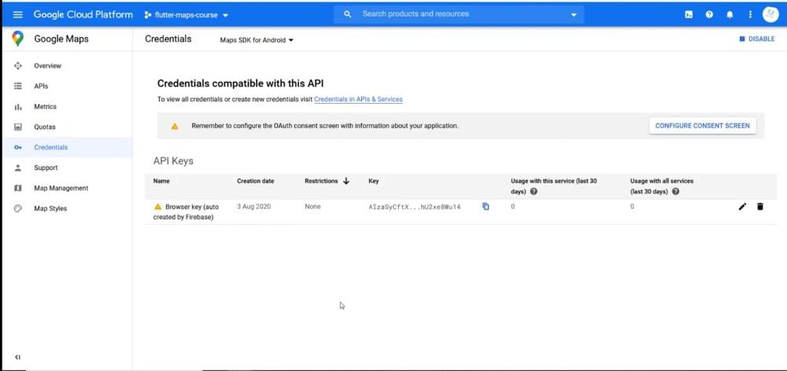**Counsel google service**

**Meta Developer**

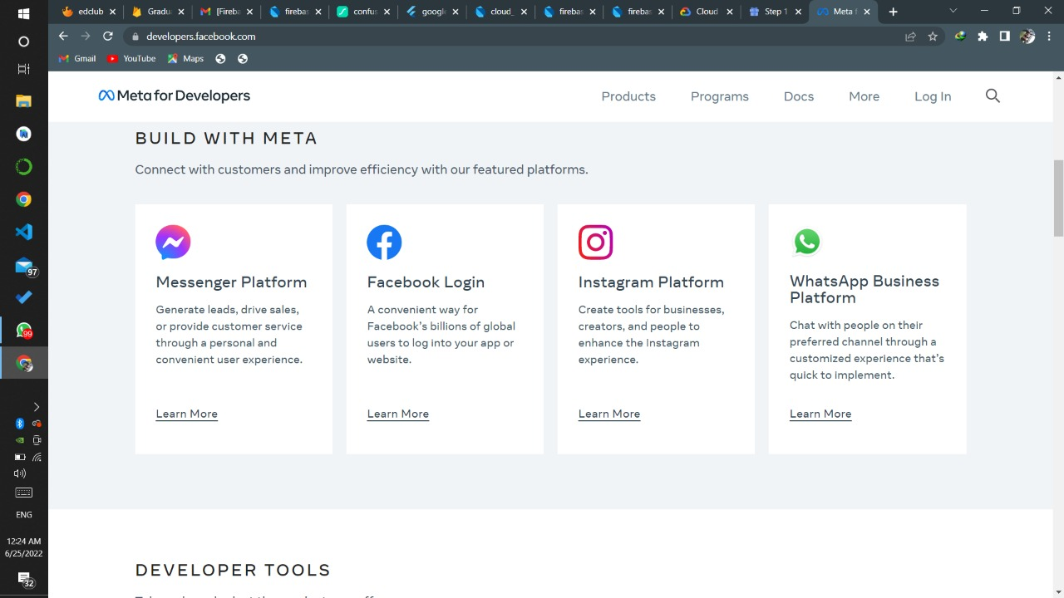

**4-Front End**

[ HTML , CSS , BOOTSTRAP , JAVASCRIPT , JQUERY , RECAT ]

**4.1 HTML**



HTML is the Standard Markup Language. It is used for developing Web Pages. HTML is Hyper Text Markup Language and is used for describing the structure of web pages. Various Tags are used in HTML like & quot, heading & quot, , & quot, paragraph & quot, , & quot, table & quot, , and so on. This paper discusses various HTML tags that are must for developing web pages.

**4.2 CSS**



* CSS stands for Cascading Style Sheets
* CSS describes how HTML elements are to be displayed on screen, paper, or in other media
* CSS saves a lot of work. It can control the layout of multiple web pages all at once
* External style-sheets are stored in CSS files

## **Why Use CSS?**

CSS is used to define styles for your web pages, including the design, layout and variations in display for different devices and screen sizes.

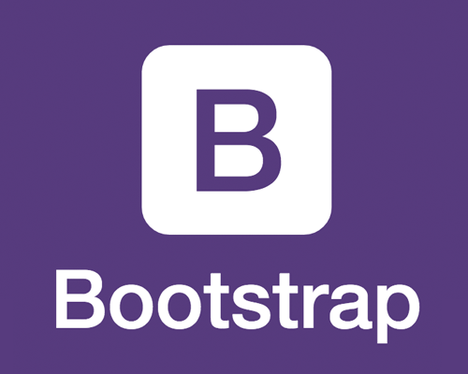**4.3 BOOTSTRAP**

**What is Bootstrap …?**

It is an open-source and free CSS framework, which helps in directing a responsive device-friendly mobile-first front-end web page development tool. Bootstrap includes the CSS (Cascading Style Sheets), and an optional JavaScript supported design template (plug-ins) that deals with typography, implementation of buttons, forms, and various other components user interface. This framework helps in faster web development and supports developers in creating responsive web pages faster.

### **Why should developers use Bootstrap?**

* ****Browser supportive****: Every browser supports this Bootstrap Framework.
* ****Mobile-first approach****: In the Bootstrap 3 framework, there is a preexisting mobile-first style all through the library and not as separate files.
* ****Simple and easy to start****: If you know HTML and CSS, you can quickly start working with Bootstrap, and its documentation is provided on the official site.
* ****Responsive design and looks****: Web pages designed using the Bootstrap framework has responsive CSS that can adjust to the screen size of large desktops, notebooks, tablets, and mobiles.
* ****Easy customization****: It provides some built-in components and functionalities that are easy for customizing.

**4.4 JAVASCRIPT**

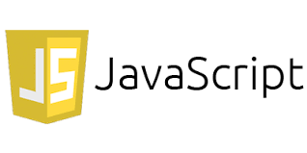

JavaScript (js) is a light-weight object-oriented programming language which is used by several websites for scripting the webpages. It is an interpreted, full-fledged programming language that enables dynamic interactivity on websites when applied to an HTML document. It was introduced in the year 1995 for adding programs to the webpages in the Netscape Navigator browser. Since then, it has been adopted by all other graphical web browsers. With JavaScript, users can build modern web applications to interact directly without reloading the page every time. The traditional website uses js to provide several forms of interactivity and simplicity.

**4.5 JQUERY**



jQuery is a fast, small, and feature-rich JavaScript library. It makes things like HTML document traversal and manipulation, event handling, animation, and Ajax much simpler with an easy-to-use API that works across a multitude of browsers. With a combination of versatility and extensibility, jQuery has changed the way that millions of people write JavaScript.

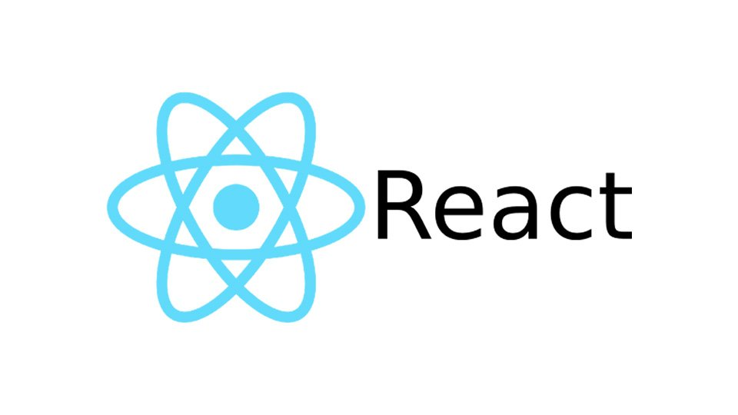**4.6 RECAT [ Framework]**

**What is React JS?**

If the aforementioned tech jargon seemed to be too tech-heavy for you, let’s head to the most basic question and break down React JS for you!

React is an open-source, declarative, and flexible JavaScript library that developers love using to build scalable, simple, and fast frontend interfaces for single-page apps or multi page web apps. Built and maintained by Facebook, it allows developers to construct large web apps that can change data without reloading a page.

React can be used with a combination of several JS libraries and frameworks like jQuery, Backbone, or even Angular in MVC. The core functionality of React is developed in a way that it makes front end development fast, modular, simple, and scalable

**5 Start UMl**



## **What is StarUML tool?**

StarUML is an open source software modeling tool that supports the UML (Unified Modeling Language) framework for system and software modeling. It actively supports the MDA (Model Driven Architecture) approach by supporting the UML profile concept and allowing to generate code for multiple languages.

**6 Virtual Box**



**What is a Virtual-box used for?**

Oracle VM Virtual-box is cross-platform virtualization software. It allows users to extend their existing computer to run multiple operating systems including Microsoft Windows, Mac OS X, Linux, and Oracle Solaris, at the same time

**Why did we use Virtual-Box ?**

To run the IOS version on an emulator that supports the Apple system environment, and therefore we used the Virtual Box program to provide us with the full environment to run this version on the Windows operating system.

**Chapter 6 [Testing]**



In this chapter we will talk about the testing tools and methodologies that we have used in our project as we used many testing tools in our project to ensure that our website and mobile application runs correctly, smoothly and without any errors.

1-) **Flutter**: for Flutter testing we have used tools like:

**[LambdaTest](https://www.lambdatest.com/selenium-automation?utm_source=Guru99&utm_medium=LT&utm_campaign=Frontend&utm_term=Listing)**:

which is a Cross Browser Testing platform. Which allows automated testing for mobile applications using its scalable, secure, and reliable cloud based Selenium grid and browser versions to maximize the test coverage.

4-) **Firebase**: for the fire-base testing we used a tool called Firebase Test Lab which enables us to Test our app on devices hosted in a Google data center.

**Firebase Test Lab**: is a cloud-based app testing infrastructure that enables us to test our app on a range of devices and configurations, so we can get a better idea of how it'll perform in the hands of live users.

We also used features provided by flutter platform that helped us to ensure that our app performs correctly while retaining our feature and bug fix velocity which falls into a the following categories:

**Unit testing tools:** A unit test tests a single function, method, or class. The goal of a unit test is to verify the correctness of a unit of logic under a variety of conditions. External dependencies of the unit under test are generally mocked out. Unit tests generally don’t read from or write to disk, render to screen, or receive user actions from outside the process running the test.

**Widget testing:** A widget test (in other UI frameworks referred to as component test) tests a single widget. The goal of a widget test is to verify that the widget UI looks and interacts as expected. Testing a widget involves multiple classes and requires a test environment that provides the appropriate widget lifestyle context.

**Integration tests:** An integration test tests a complete app or a large part of an app. The goal of an integration test is to verify that all the widgets and services being tested work together as expected. Furthermore, you can use integration tests to verify our app’s performance.

And for the fire-base testing we used a tool called Firebase Test Lab which enables us to Test our app on devices hosted in a Google data center.



**Selenium**: Selenium is a full stack testing tool. It performs end to end testing across various browsers & platforms like Windows, Mac, and Linux. It allows you to write tests in different programming languages like Java, PHP, C#, etc. and we used that tool to test our PHP code.

1. **Front-end**: for the Front-end testing we used:

**[LambdaTest](https://www.lambdatest.com/selenium-automation?utm_source=Guru99&utm_medium=LT&utm_campaign=Frontend&utm_term=Listing)**: which is a Cross Browser Testing platform. Which allows automated web testing using its scalable, secure, and reliable cloud based Selenium grid and browser versions to maximize the test coverage.



**[JSHint](https://jshint.com/)**: which is a tool that helps to detect errors and potential problems in our JavaScript code.

**[Page Speed](https://developers.google.com/speed)**: Page speed is an open source performance testing add-on launched by Google. The tool evaluates the web page and provides suggestions to minimize loading time. It makes web page retrieval quicker when users access web pages using Google search engine.

**Chapter 7**

**Conclusion & Future Work**



In this chapter we will talk about Conclusion and future work :-

**Conclusion :-**

* Project objectives were achieved. After equipped with a clear statement of system requirements and design specifications, the application was developed using android studio and The system is successfully designed and implemented correctly and the Shtably Android & IOS application system is now working properly.
* The application is designed with system requirements in mind; Fully meets all specific requirements.
* Object-oriented approach was used during development to maximize code reuse and this reduce development time.
* At the conclusion of each unit, system coding was tested for linguistic and logical errors, and this process was performed on gradual basics until the entire system as a whole was tested. Currently,
* The application can help the user to create a maintenance request or to purchase products from the application store

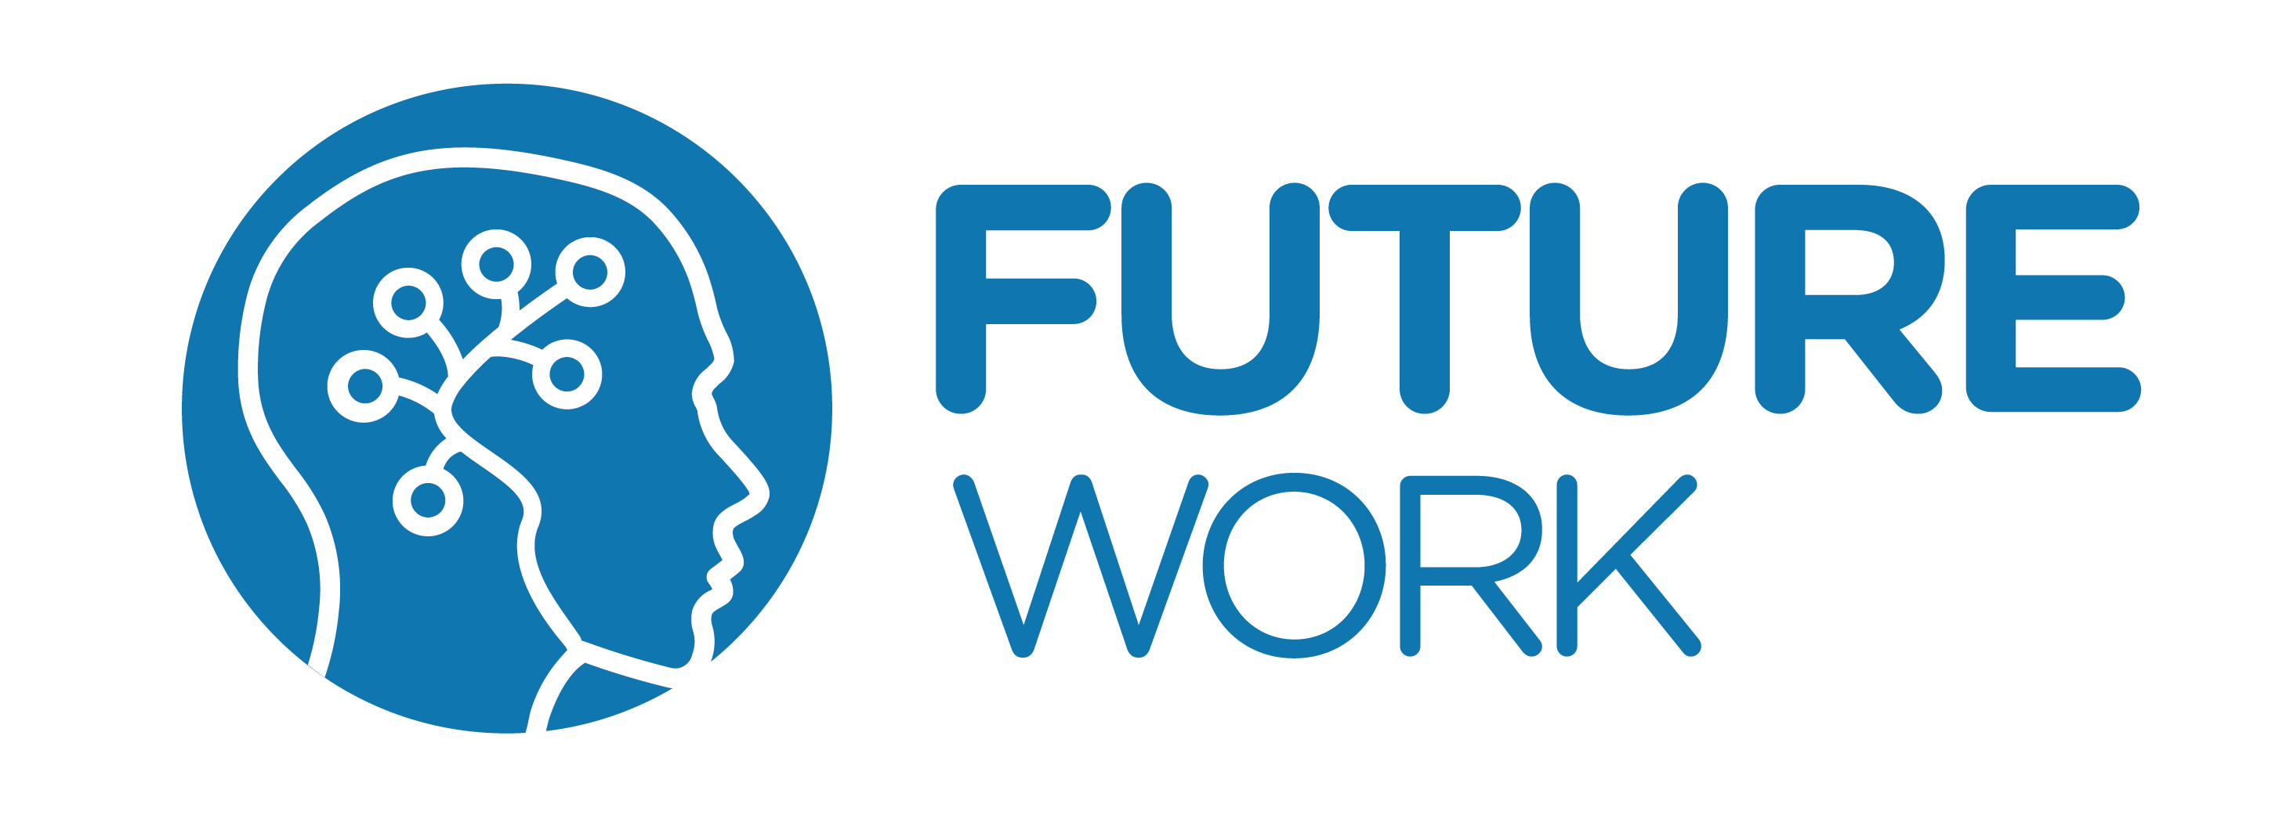**In this chapter we will talk about the future work that we might do in the upcoming future as we planning to add some features like:**

1-Add a premium account: we consider adding a premium account to the users to use specific features.

2-Create a career hub: create a career hub for unorganized workers to work in companies and in our company.

3-Create a payment process system: for workers, shops, and companies.

4-Create a Privet chat in our project to connect clients, workers,shops, and companies all together.

5-Add a detection to Toxicity: Add a detection to Toxic comments using Toxicity Analyze Toxicity with Perspective API to get toxicity scores from Perspective API for comments written to a Cloud Firestore collection.

6-Using data analysis: use data analysis to add certain features to our application and website such as adding offers on products based on the number of sold items of that product and the similar products of that item.

7-Using data analysis: to create a recommendation system based on certain factors such as shop, and company rating, and the number of sold items of that shop, company.

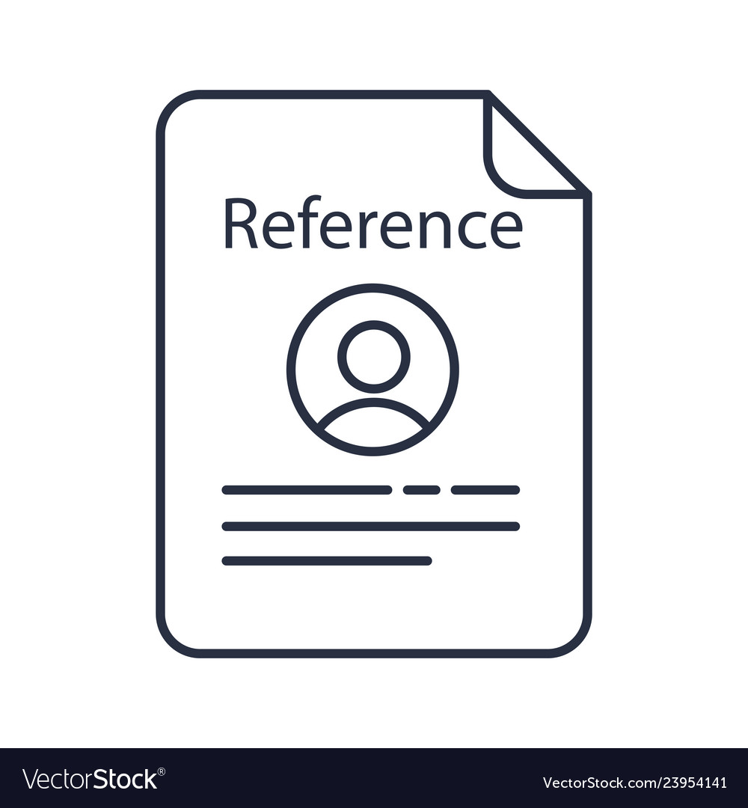

**Web Sites :-**

1. <https://firebase.flutter.dev/docs/overview/>
2. <https://en.wikipedia.org/wiki/Flutter_(software)>
3. <https://www.w3schools.com/>
4. <https://developer.mozilla.org/fr/>
5. <https://www.javascript.com/>
6. <https://docs.flutter.dev/>
7. <https://firebase.flutter.dev/docs/overview>
8. <https://reactjs.org/docs/getting-started.html>
9. <https://developer.mozilla.org/en-US/>
10. [https://www.adobe.com/mena_ar/products/xd/ features/ui-kits.html](https://www.adobe.com/mena_ar/products/xd/features/ui-kits.html)

**Books :-**

1. **Flutter in Action Eric Windmill January 2020**
2. **Beginning Flutter: A Hands On Guide to App Development By Marco L. Napoli 2019**
3. **Beginning App Development with Flutter: Create Cross Platform Mobile Apps By Rap Payne 2019**
4. **Practical UI Patterns for Design Systems By Diana MacDonald 2019**
5. **Frameworkless Front-End Development By Francesco Strazzullo 2019**

